

Flood Resilience in Dar es Salaam:

An Introduction to New Tools and Methodologies for Flood Resilience using QGIS and InaSAFE

**GIS and InaSAFE workshops**

A two day course intended to ‘socialise’ the attendees with the basic workflows typically carried out when performing a natural disaster scenario analysis with QGis and InaSAFE.





|  |  |  |
| --- | --- | --- |
| qgis-icon-60x60.pngKartoza.com.png  Logo-monochrome-black.png  InaSAFE is funded by DFAT.pnggfdrr-large.jpg | | |
|  | | |

# Preface

Ramani Huria is a community-based mapping project in Dar Es Salaam, Tanzania. Ramani Huria is training teams of local university students and community members from throughout Dar Es Salaam to use OpenStreetMap to create sophisticated and highly-accurate maps of (at least) 20 different wards. These wards were selected because they are the most flood-prone areas of the city. These maps can be used as the basis for analysis in InaSAFE, a free software that enables users to run realistic natural disaster scenarios for better planning and response.

Ramani Huria is looking forward to working with the Tanzanian Prime Minister’s Office, Department of Disaster Management in exploring the possibilities to use the data generated during this project to it’s fullest extent.

Course Objectives

Will introduce you to the concept of GIS and the QGIS (<http://qgis.org>) Free Software that allows you to visualise, capture, edit, analyse spatial data, and then produce print ready maps.Having a basic understanding of QGIS is needed in order to effectively be able to use InaSAFE.

Course content

All of the content, for this course are available for free and can be freely shared and redistributed under the [Creative Commons Attribution 4.0 International, CC-by-sa](https://creativecommons.org/licenses/by-sa/4.0/) license. Parts of this course content were extracted and modified from the QGIS training manual course content available at <http://docs.qgis.org/2.8/en/docs/training_manual/>.

Data used for this course was provided by:

* The OpenStreetmap Project and is **© OpenStreetMap contributors**
* Attribution for DEMS: Tanzania Open Data Initiative
* Attribution for Sensefly mosaic: Tanzania Open Data Initiative

All of the content used in this course (i.e. the document you are reading and essential files for following the instructions) can be found [here](https://drive.google.com/folderview?id=0B8Vft3QRhetbflAxajR4VFc3cnhtVzY1eE15QUhFS2djOGJuZ3NQREFYWjFfZXZPYnNYZ2M&usp=sharing).

# 

# List of supplied datasets

## GIS Training Inputs:

* Tandale Imagery: a clipped image from the Tandale sensefly mosaic
* Tandale DEM: a clipped DEM corresponding to the imagery above
* Tandale DSM: a clipped DSM derived from the DEM above
* OSM Roads
* OSM Buildings
* OSM Political

## GIS Training outputs:

* Digitising roads from imagery (type [Highway, tertiary, secondary, suburban], name)
* Building footprints from imagery (type [House, Office, School, Place of worship], levels)
* Wards polygons (name) - wards should avoid intersection

# Key skills

## QGIS

* Basic QGIS Usage
  + navigation, pan & zoom
  + add vector layer
  + add raster layer
  + save and restore project
  + query feature attributes
  + view attribute table
  + setting CRS
* Cartography
  + Basic symbolisation - lines and polygons
  + Single symbol renderer
  + Classified renderer
  + Labelling
* Editing
  + Add a feature
  + Ensure topological correctness
  + Delete a feature
  + Edit a feature
  + Add new attributes
  + Edit attribute values
* Map composition
  + Add a map to the layout
  + Add a legend
  + Add a scalebar
  + Add a title
  + Add a north arrow
  + Add a logo
  + Generate a PDF

Contents

# Introduction to QGIS

# [1. Module: The Interface](#h.sbu0ohf5yk45)

* [1.1. Lesson: A Brief Introduction](#h.18pw14dn8ioa)
  + [1.1.1. How to use this tutorial](#h.o3nx7ukvujnq)
  + [1.1.2. Tiered course objectives](#h.7ekwdjuaxjqv)
  + [1.1.3. Why QGIS?](#h.2zop10u1ldu9)
* [1.2. Lesson: Adding your first layer](#h.qrc3owk4nqgy)
  + [1.2.1. Follow Along: Prepare a map](#h.1w2d9mvwqwxx)
  + [1.2.2. In Conclusion](#h.m1kvmq534rqr)
* [1.3. Lesson: An Overview of the Interface](#h.ly6vcrozg8j2)
  + [1.3.1. Try Yourself: The Basics](#h.iegl3sev18ah)
  + [1.3.2. Try Yourself 1](#h.2e7nor6t6hr)
  + [1.3.3. Try Yourself 2](#h.s7gf5oz9mvut)

## 2. Module: Classifying Vector Data

Classifying vector data allows you to assign different symbols to features (different objects in the same layer), depending on their attributes. This allows someone who uses the map to easily see the attributes of various features.

* [2.1. Lesson: Attribute Data](#h.xqal6f16wxdb)
  + [2.1.1. Follow Along: Attribute data](#h.1qxvwm56e1wg)
  + [2.1.2. In Conclusion](#h.4bxsgpjcbkz)
* [2.2. Lesson: The Label Tool](#h.in9lptf5ko7y)
  + [2.2.1. Follow Along: Using Labels](#h.p9mk48gg40k)
  + [2.2.2. Follow Along: Changing Label Options](#h.m779z5bbd8il)
  + [2.2.3. Follow Along: Using Labels Instead of Layer Symbology](#h.ongnm5rqgl2o)
  + [2.2.4. Try Yourself Customize the Labels](#h.sal8zi2zlqyc)
  + [2.2.5. Follow Along: Labeling Lines](#h.8tox0v3b6e8j)
  + [2.2.9. In Conclusion](#h.5p01brbdkhgj)
* [2.3. Lesson: Classification](#h.5oqnbg456knx)
  + [2.3.1. Follow Along: Classifying Nominal Data](#h.245ki573thum)
  + [2.3.2. Try Yourself More Classification](#h.1xmohq5zvca7)
  + [2.3.3. Follow Along: Ratio Classification](#h.g5rj6gk2fkpq)
  + [2.3.4. Try Yourself Refine the Classification](#h.c02ubp95zs2o)
  + [2.3.5. In Conclusion](#h.uy93wfn55gbq)

# 3. Module: Creating Vector Data

Creating maps using existing data is just the beginning. In this module, you’ll learn how to modify existing vector data and create new datasets entirely.

* [3.1. Lesson: Creating a New Vector Dataset](#h.1em62wdu5jpn)
  + [3.1.1. Follow Along: The Layer Creation Dialog](#h.z311bwkjwjha)
  + [3.1.2. Follow Along: Data Sources](#h.tg3yr7nbg314)
  + [3.1.3. Try Yourself](#h.227mlmid1een)
  + [3.1.4. Try Yourself](#h.e7vfn0nvomyc)
  + [3.1.5. In Conclusion](#h.p4m6tz13okli)
* [3.2. Lesson: Feature Topology](#h.bwgfwud640h)
  + [3.2.1. Follow Along: Snapping](#h.td7gpg5c5p88)
  + [3.2.2. Follow Along: Correct Topological Features](#h.qoiw0qomvcbw)
  + [3.2.3. In Conclusion](#h.lksisohz6307)

# 4. Module: Rasters

We’ve used rasters for digitizing before, but raster data can also be used directly. In this module, you’ll see how it’s done in QGIS.

* [4.1. Lesson: Working with Raster Data](#h.i61zbyn8culd)
  + [4.1.1. Follow Along: Loading Raster Data](#h.5x0zytb51o2n)
  + [4.1.2. In Conclusion](#h.27sns26s8ize)
* [4.2. Lesson: Changing Raster Symbology](#h.yvf0j37wdv5c)
  + [4.2.1. Try Yourself](#h.byhahlo933dl)
  + [4.2.2. Follow Along: Changing Raster Layer Symbology](#h.58zlp7j3k3rk)
  + [4.2.3. In Conclusion](#h.yrw4dnrvdyaq)
* [4.3. Lesson: Terrain Analysis](#h.c7ksvrro92lw)
  + [4.3.1. Follow Along: Calculating a Hillshade](#h.ys2gzllqjun7)
  + [4.3.2. Follow Along: Using a Hillshade as an Overlay](#h.cxut4nj75tpi)
  + [4.3.3. Follow Along: Using the Raster Calculator](#h.pm35z04um24r)
  + [4.3.4. In Conclusion](#h.newlar726ufv)

# 5. Module: Creating Maps

In this module, you’ll learn how to use the QGIS Map Composer to produce quality maps with all the requisite map components.

* 5.1. Lesson: Using Map Composer
  + [5.1.1. Follow Along: The Composer Manager](#h.v89t4lxvprxr)
  + [5.1.2. Follow Along: Basic Map Composition](#h.7ih19t5pfkml)
  + [5.1.3. Follow Along: Adding a Title](#h.d5hl54ysudx6)
  + [5.1.4. Follow Along: Adding a Legend](#h.upk39fmcqiap)
  + [5.1.5. Follow Along: Customizing Legend Items](#h.mqmxamgbs6fx)
  + [5.1.6. Follow Along: Exporting Your Map](#h.piy2w094vojy)
  + [5.1.7. In Conclusion](#h.cx1wxe86syb3)

# 1.1. Lesson: A Brief Introduction

# Welcome to our course! Over the next few days, we’ll be showing you how to use QGIS easily and efficiently. If you’re new to GIS, we’ll tell you what you need to get started. If you’re an experienced user, you’ll see how QGIS fulfills all the functions you expect from a GIS program, and more!

# In this module we introduce the QGIS project itself, as well as explaining the user interface.

# After completing this section, you will be able to correctly identify the main elements of the screen in QGIS and know what each of them does, and load a shapefile into QGIS.

# Warning

# This course includes instructions on adding, deleting and altering GIS datasets. We have provided training datasets for this purpose. Before using the techniques described here on your own data, always ensure you have proper backups!

## 1.1.1. How to use this tutorial

# Any text *that looks like this* refers to something on the screen that you can click on.

# Text that *looks ‣ like ‣ this* directs you through menus.

# This kind of text refers to something you can type, such as a command, path, or file name.

## 1.1.2. Tiered course objectives

# This course caters to different user experience levels. Depending on which category you consider yourself to be in, you can expect a different set of course outcomes. Each category contains information that is essential for the next one, so it’s important to do all exercises that are at or below your level of experience.

## 2.1.2.1. basic Basic

# In this category, the course assumes that you have little or no prior experience with theoretical GIS knowledge or the operation of a GIS program.

# Limited theoretical background will be provided to explain the purpose of an action you will be performing in the program, but the emphasis is on learning by doing.

# When you complete the course, you will have a better concept of the possibilities of GIS, and how to harness their power via QGIS.

### 2.1.2.2. moderate Intermediate

# In this category, it is assumed that you have working knowledge and experience of the everyday uses of GIS.

## 1.2. Lesson: Adding your first layer

We will start the application, and create a basic map to use for examples and exercises.

**The goal for this lesson:** To get started with an example map.

Note

Before starting this exercise, QGIS must be installed on your computer. Also, download the training\_manual\_exercise\_data.zip file from the [QGIS data downloads area](http://qgis.org/downloads/data/).

Launch QGIS from its desktop shortcut, menu item, etc., depending on how you configured its installation.

Note

The screenshots for this course were taken in QGIS 2.0 running on MacOS. Depending on your setup, the screens you encounter may well appear somewhat different. However, all the same buttons will still be available, and the instructions will work on any OS. You will need QGIS 2.0 (the latest version at time of writing) to use this course.

Let’s get started right away!

## 1.2.1. basic Follow Along: Prepare a map

* Open QGIS. You will have a new, blank map.
* Look for the *Add Vector Layer* button:
* Click on it to open the following dialog:

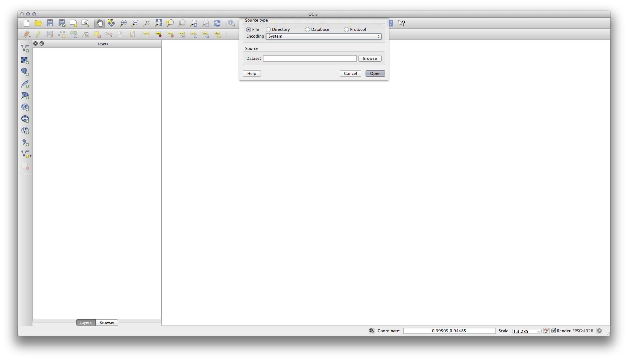

* Click on the *Browse* button and navigate to the file exercise\_data/epsg4326/roads.shp (in your course directory). With this file selected, click *Open*. You will see the original dialog, but with the file path filled in. Click *Open* here as well. The data you specified will now load.

Congratulations! You now have a basic map. Now would be a good time to save your work.

* Click on the *Save As* button:
* Save the map under exercise\_data/ and call it basic\_map.qgs.

## 1.2.2. In Conclusion

You’ve learned how to add a layer and create a basic map!

# 1.3. Lesson: An Overview of the Interface

We will explore the QGIS user interface so that you are familiar with the menus, toolbars, map canvas and layers list that form the basic structure of the interface.

**The goal for this lesson:** To understand the basics of the QGIS user interface.

## 1.3.1. basic Try Yourself: The Basics

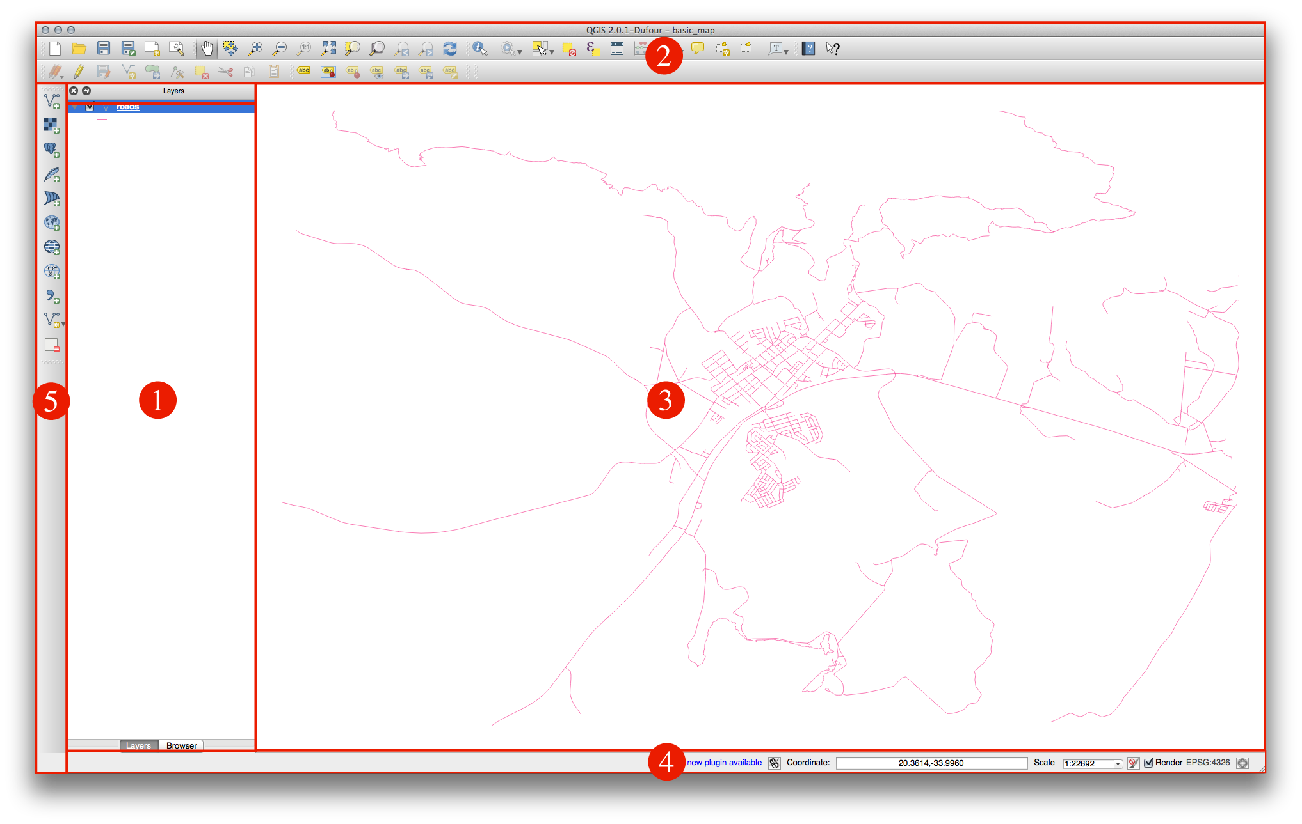

The elements identified in the figure above are:

1. Layers List / Browser Panel
2. Toolbars
3. Map canvas
4. Status bar
5. Side Toolbar

### 1.3.1.1. basic The Layers List

In the Layers list, you can see a list, at any time, of all the layers available to you.

Expanding collapsed items (by clicking the arrow or plus symbol beside them) will provide you with more information on the layer’s current appearance.

Right-clicking on a layer will give you a menu with lots of extra options. You will be using some of them before long, so take a look around!

Some versions of QGIS have a separate *Control rendering order* checkbox just underneath the Layers list. Don’t worry if you can’t see it. If it is present, ensure that it’s checked for now.

Note

A vector layer is a dataset, usually of a specific kind of object, such as roads, trees, etc. A vector layer can consist of either points, lines or polygons.

### 1.3.1.2. basic The Browser Panel

The QGIS Browser is a panel in QGIS that lets you easily navigate in your database. You can have access to common vector files (e.g. ESRI shapefile or MapInfo files), databases (e.g.PostGIS, Oracle, Spatialite or MSSQL Spatial) and WMS/WFS connections. You can also view your GRASS data.

### 1.3.1.3. basic Toolbars

Your most oft-used sets of tools can be turned into toolbars for basic access. For example, the File toolbar allows you to save, load, print, and start a new project. You can easily customize the interface to see only the tools you use most often, adding or removing toolbars as necessary via the *View ‣ Toolbars* menu.

Even if they are not visible in a toolbar, all of your tools will remain accessible via the menus. For example, if you remove the *File* toolbar (which contains the *Save* button), you can still save your map by clicking on the *File* menu and then clicking on *Save*.

### 1.3.1.4. basic The Map Canvas

This is where the map itself is displayed.

### 1.3.1.5. basic The Status Bar

Shows you information about the current map. Also allows you to adjust the map scale and see the mouse cursor’s coordinates on the map.

## 1.3.2. basic Try Yourself 1

Try to identify the four elements listed above on your own screen, without referring to the diagram above. See if you can identify their names and functions. You will become more familiar with these elements as you use them in the coming days.

## 1.3.3. basic Try Yourself 2

Try to find each of these tools on your screen. What is their purpose?

1. 
2. 
3. 
4. 
5. 

Note

If any of these tools is not visible on the screen, try enabling some toolbars that are currently hidden. Also keep in mind that if there isn’t enough space on the screen, a toolbar may be shortened by hiding some of its tools. You can see the hidden tools by clicking on the double right arrow button in any such collapsed toolbar. You can see a tooltip with the name of any tool by holding your mouse over the tool for a while.

# Following the instructions for the beginner level will provide you with familiar ground, as well as to make you aware of the cases where QGIS does things slightly differently from other software you may be used to. You will also learn how to use analysis functions in QGIS.

# When you complete the course, you should be comfortable with using QGIS for all of the functions you usually need from a GIS for everyday use.

### 1.1.2.3. hard Advanced

# In this category, the assumption is that you are experienced with GIS, have knowledge of and experience with spatial databases, using data on a remote server, perhaps writing scripts for analysis purposes, etc.

# Following the instructions for the other two levels will familiarize you with the approach that the QGIS interface follows, and will ensure that you know how to access the basic functions that you need. You will also be shown how to make use of QGIS’ plugin system, database access system, and so on.

# When you complete the course, you should be well-acquainted with the everyday operation of QGIS, as well as its more advanced functions.

## 1.1.3. Why QGIS?

# As information becomes increasingly spatially aware, there is no shortage of tools able to fulfill some or all commonly used GIS functions. Why should anyone be using QGIS over some other GIS software package?

# Here are only some of the reasons:

# *It’s free, as in lunch.* Installing and using the QGIS program costs you a grand total of zero money. No initial fee, no recurring fee, nothing.

# *It’s free, as in liberty.* If you need extra functionality in QGIS, you can do more than just hope it will be included in the next release. You can sponsor the development of a feature, or add it yourself if you are familiar with programming.

# *It’s constantly developing.* Because anyone can add new features and improve on existing ones, QGIS never stagnates. The development of a new tool can happen as quickly as you need it to.

# *Extensive help and documentation is available.* If you’re stuck with anything, you can turn to the extensive documentation, your fellow QGIS users, or even the developers.

# *Cross-platform.* QGIS can be installed on MacOS, Windows and Linux.

# Now that you know why you want to use QGIS, we can show you how. The first lesson will guide you in creating your first QGIS map.

# 

# 2.1. Lesson: Attribute Data

# Up to now, none of the changes we have made to the map have been influenced by the objects that are being shown. In other words, all the land use areas look alike, and all the roads look alike. When looking at the map, the viewers don’t know anything about the roads they are seeing; only that there is a road of a certain shape in a certain area.

# But the whole strength of GIS is that all the objects that are visible on the map also have attributes. Maps in a GIS aren’t just pictures. They represent not only objects in locations, but also information about those objects.

# **The goal of this lesson:** To explore the attribute data of an object and understand what the various data can be useful for.

## 2.1.1. basic Follow Along: Attribute data

# Open the attribute table for the *places* layer (refer back to the section *“Working with Vector Data”* if necessary). Which field would be the most useful to represent in label form, and why?

# 

## 2.1.2. In Conclusion

# You now know how to use the attribute table to see what is actually in the data you’re using. Any dataset will only be useful to you if it has the attributes that you care about. If you know which attributes you need, you can quickly decide if you’re able to use a given dataset, or if you need to look for another one that has the required attribute data.

## 2.2. Lesson: The Label Tool

# Labels can be added to a map to show any information about an object. Any vector layer can have labels associated with it. These labels rely on the attribute data of a layer for their content.

# Note

# The *Layer Properties* dialog does have a *Labels* tab, which now offers the same functionality, but for this example we’ll use the *Label tool*, accessed via a toolbar button.

# **The goal for this lesson:** To apply useful and good-looking labels to a layer.

## 2.2.1. basic Follow Along: Using Labels

# Before being able to access the Label tool, you will need to ensure that it has been activated.

# Go to the menu item *View ‣ Toolbars*.

# Ensure that the *Label* item has a check mark next to it. If it doesn’t, click on the *Label* item, and it will be activated.

# Click on the *places* layer in the *Layers list*, so that it is highlighted.

# Click on the following toolbar button:mActionLabeling

# This gives you the *Layer labeling settings* dialog.

# Check the box next to *Label this layer with...*.

# You’ll need to choose which field in the attributes will be used for the labels. In the previous lesson, you decided that the NAME field was the most suitable one for this purpose.

# Select *name* from the list:

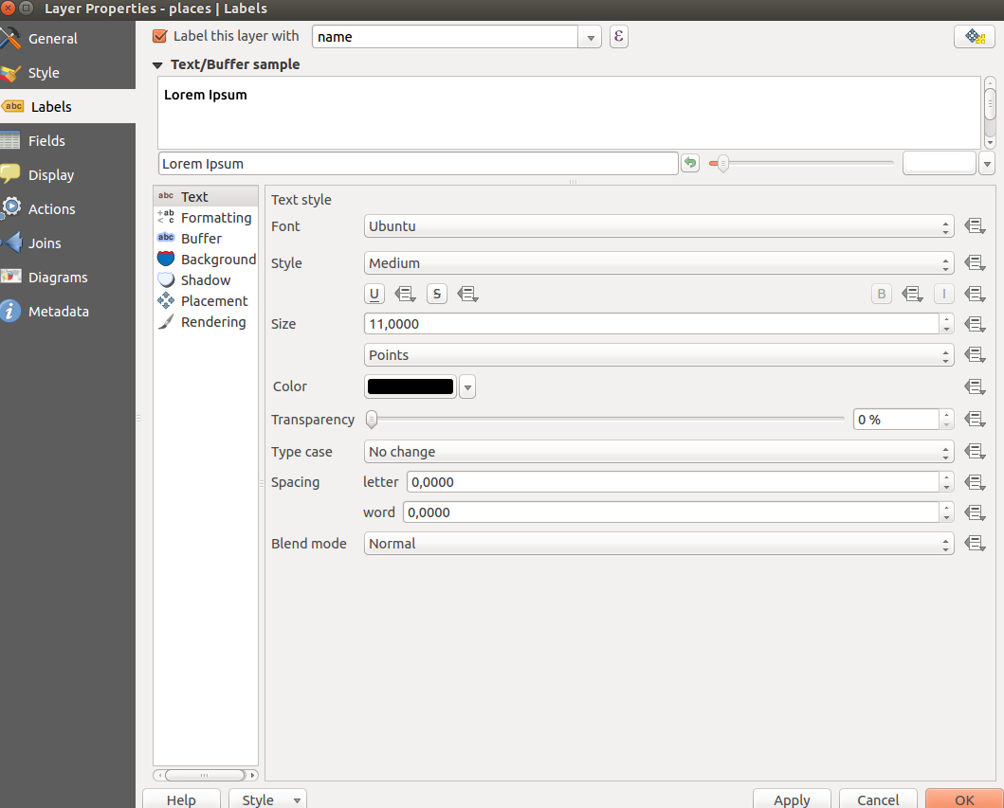

# 

# Click *OK*.

# The map should now have labels like this:

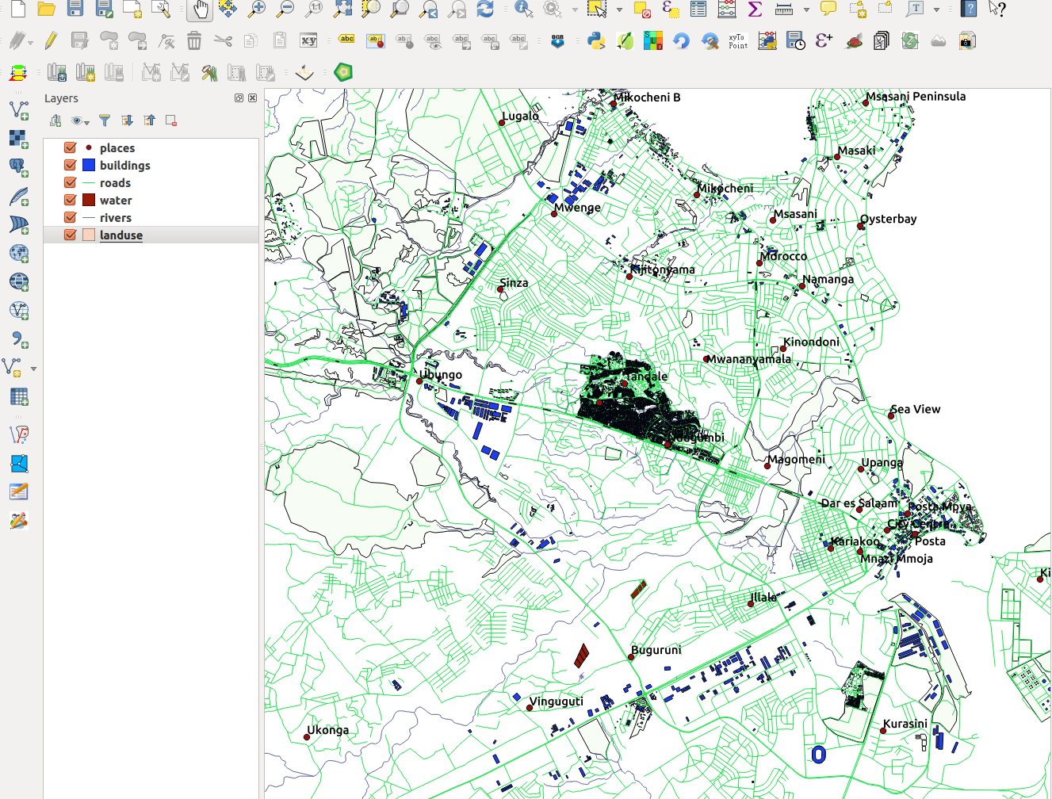

# 

## 2.2.2. basic Follow Along: Changing Label Options

# Depending on the styles you chose for your map in earlier lessons, you’ll might find that the labels are not appropriately formatted and either overlap or are too far away from their point markers.

# Open the *Label tool* again by clicking on its button as before.

# Make sure *Text* is selected in the left-hand options list, then update the text formatting options to match those shown here:

# ../../../_images/label_formatting_options.png

# That’s the font problem solved! Now let’s look at the problem of the labels overlapping the points, but before we do that, let’s take a look at the *Buffer* option.

# Open the *Label tool* dialog.

# Select *Buffer* from the left-hand options list.

# Select the checkbox next to *Draw text buffer*, then choose options to match those shown here:

# ../../../_images/buffer_options.png

# Click *Apply*.

# You’ll see that this adds a colored buffer or border to the place labels, making them easier to pick out on the map:

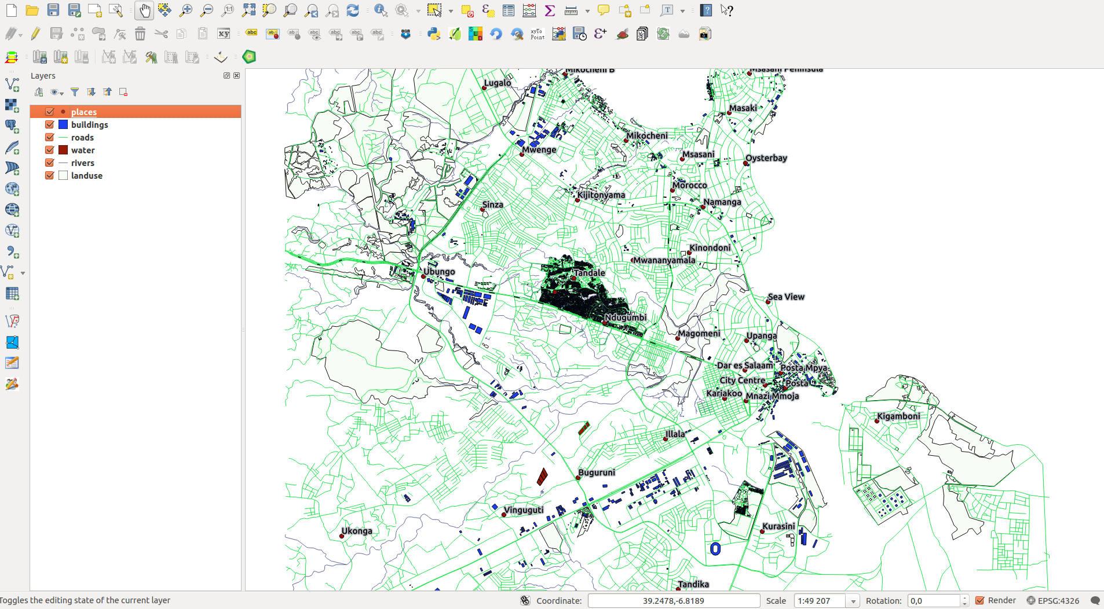

# 

# Now we can address the positioning of the labels in relation to their point markers.

# In the *Label tool* dialog, go to the *Placement* tab.

# Change the value of *Distance* to 2mm and make sure that *Around point* is selected:

# ../../../_images/offset_placement_settings.png

# Click *Apply*.

# You’ll see that the labels are no longer overlapping their point markers.

## 2.2.3. moderate Follow Along: Using Labels Instead of Layer Symbology

# In many cases, the location of a point doesn’t need to be very specific. For example, most of the points in the *places* layer refer to entire towns or suburbs, and the specific point associated with such features is not that specific on a large scale. In fact, giving a point that is too specific is often confusing for someone reading a map.

# To name an example: on a map of the world, the point given for the European Union may be somewhere in Poland, for instance. To someone reading the map, seeing a point labeled *European Union* in Poland, it may seem that the capital of the European Union is therefore in Poland.

# So, to prevent this kind of misunderstanding, it’s often useful to deactivate the point symbols and replace them completely with labels.

# In QGIS, you can do this by changing the position of the labels to be rendered directly over the points they refer to.

# Open the *Layer labeling settings* dialog for the *places* layer.

# Select the *Placement* option from the options list.

# Click on the *Offset from point* button.

# This will reveal the *Quadrant* options which you can use to set the position of the label in relation to the point marker. In this case, we want the label to be centered on the point, so choose the center quadrant:

# ../../../_images/quadrant_offset_options.png

# Hide the point symbols by editing the layer style as usual, and setting the size of the *Ellipse marker* width and height to 0:

# ../../../_images/hide_point_marker.png

# Click *OK* and you’ll see this result:

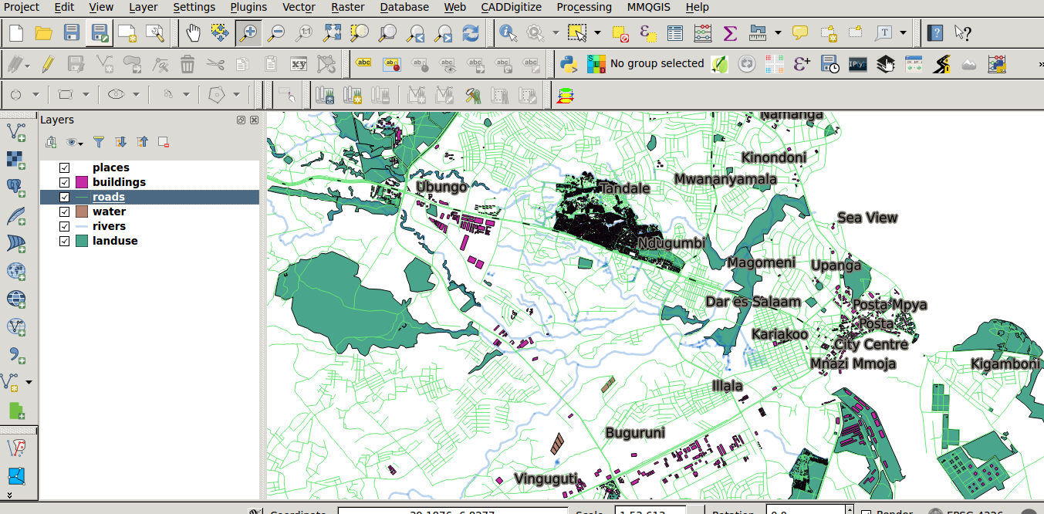

# 

# If you were to zoom out on the map, you would see that some of the labels disappear at larger scales to avoid overlapping. Sometimes this is what you want when dealing with datasets that have many points, but at other times you will lose useful information this way. There is another possibility for handling cases like this, which we’ll cover in a later exercise in this lesson.

## 2.2.4. moderate Try Yourself Customize the Labels

# Return the label and symbol settings to have a point marker and a label offset of 2.00mm. You may like to adjust the styling of the point marker or labels at this stage.

# 

# Set the map to the scale 1:100000. You can do this by typing it into the *Scale* box in the *Status Bar*.

# Modify your labels to be suitable for viewing at this scale.

## 2.2.5. moderate Follow Along: Labeling Lines

# Now that you know how labeling works, there’s an additional problem. Points and polygons are easy to label, but what about lines? If you label them the same way as the points, your results would look like this:

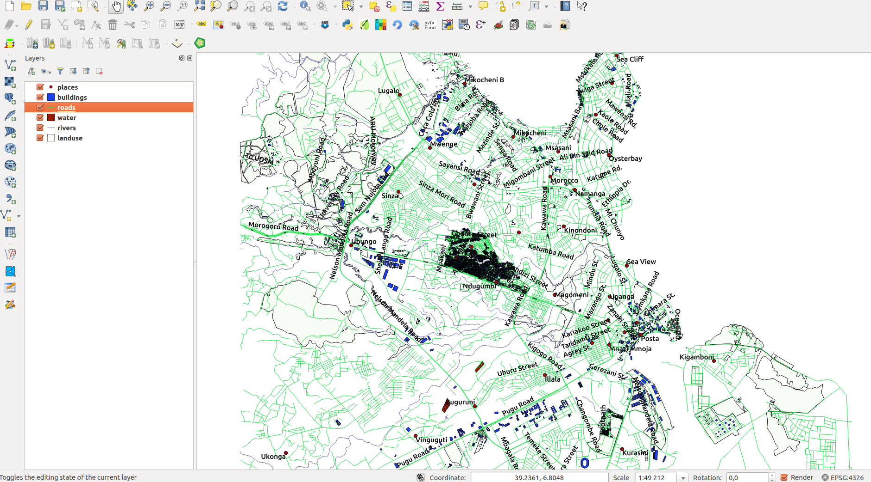

# 

# We will now reformat the *roads* layer labels so that they are easy to understand.

# Hide the *Places* layer so that it doesn’t distract you.

# Activate labels for the *streets* layer as before.

# Set the font *Size* to 10 so that you can see more labels.

# Zoom in on the Dar es Salaam town area.

# In the *Label tool* dialog’s *Advanced* tab, choose the following settings:

# ../../../_images/street_label_settings.png

# You’ll probably find that the text styling has used default values and the labels are consequently very hard to read. Set the label text format to have a dark-grey or black Color and a light-yellow buffer.

# The map will look somewhat like this, depending on scale:

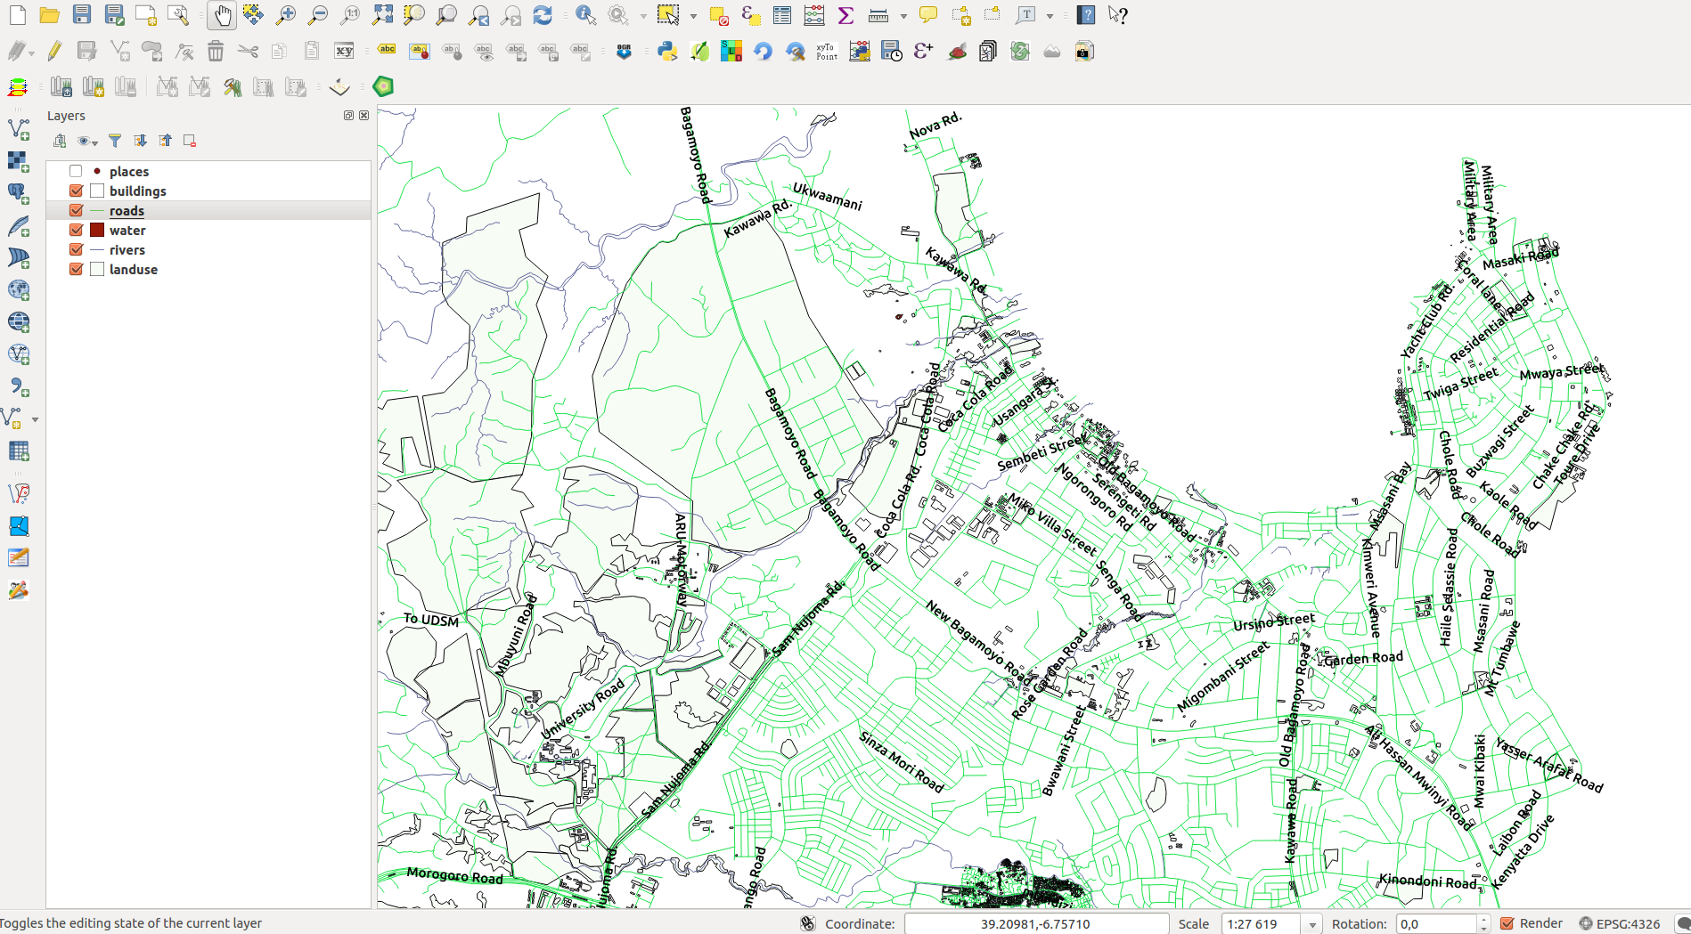

# 

# You’ll see that some of the road names appear more than once and that’s not always necessary. To prevent this from happening:

# In the *Label labelling settings* dialog, choose the *Rendering* option and select the *Merge connected lines to avoid duplicate labels*:

# ../../../_images/merge_lines_option.png

# Click *OK*

# Another useful function is to prevent labels being drawn for features too short to be of notice.

# In the same *Rendering* panel, set the value of *Suppress labeling of features smaller than ...* to 5mm and note the results when you click *Apply*.

# Try out different *Placement* settings as well. As we’ve seen before, the *horizontal* option is not a good idea in this case, so let’s try the *curved* option instead.

# Select the *Curved* option in the *Placement* panel of the *Layer labeling settings* dialog.

# Here’s the result:

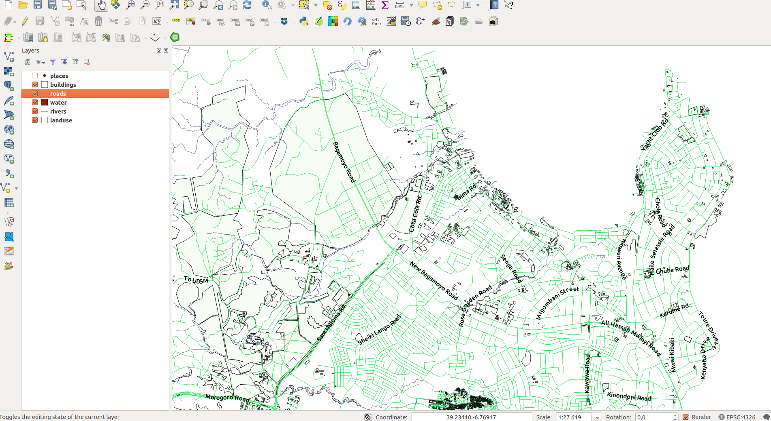

# 

# As you can see, this hides a lot of the labels that were previously visible, because of the difficulty of making some of them follow twisting street lines and still be legible. You can decide which of these options to use, depending on what you think seems more useful or what looks better.

## 2.2.9. In Conclusion

# You’ve learned how to use layer attributes to create dynamic labels. This can make your map a lot more informative and stylish!

# 2.3. Lesson: Classification

Labels are a good way to communicate information such as the names of individual places, but they can’t be used for everything. For example, let’s say that someone wants to know what each *land use* area is used for. Using labels, you’d get this:

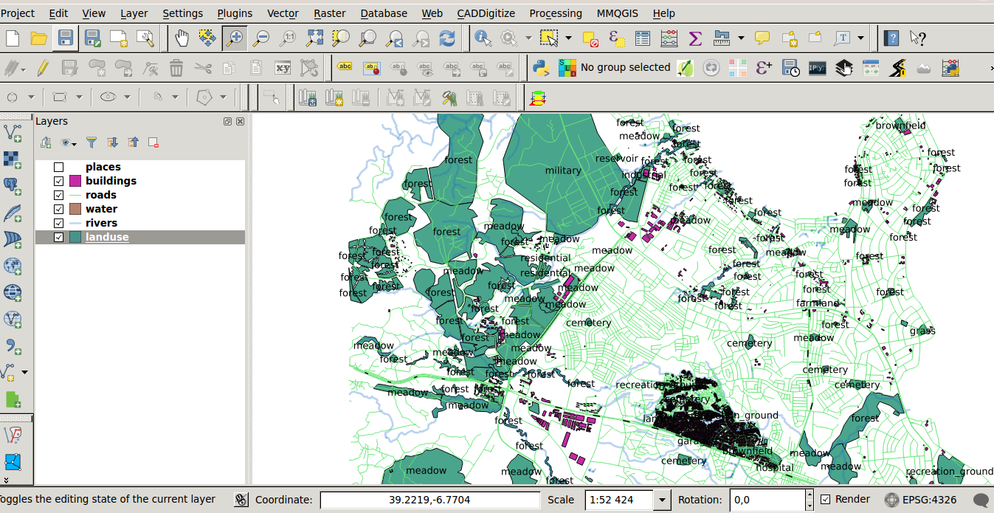

This makes the map’s labeling difficult to read and even overwhelming if there are numerous different land use areas on the map.

**The goal for this lesson:** To learn how to classify vector data effectively.

## 2.3.1. basic Follow Along: Classifying Nominal Data

* Open the *Layer Properties* dialog for the *landuse* layer.
* Go to the *Style* tab.
* Click on the dropdown that says *Single Symbol* and change it to *Categorized*:

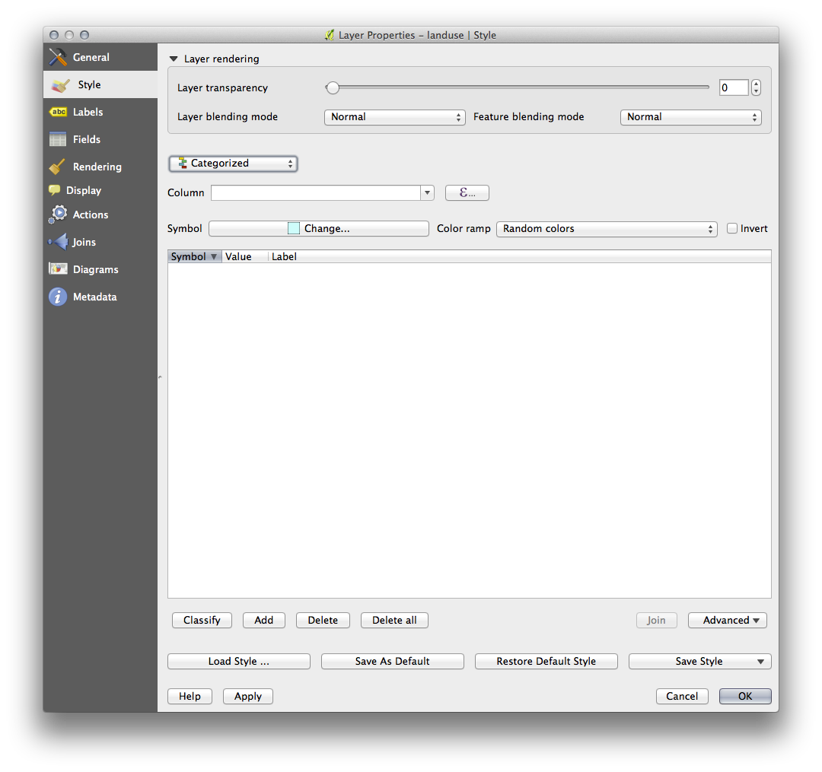

* In the new panel, change the *Column* to *landuse* and the *Color ramp* to *Greens*.
* Click the button labeled *Classify*:

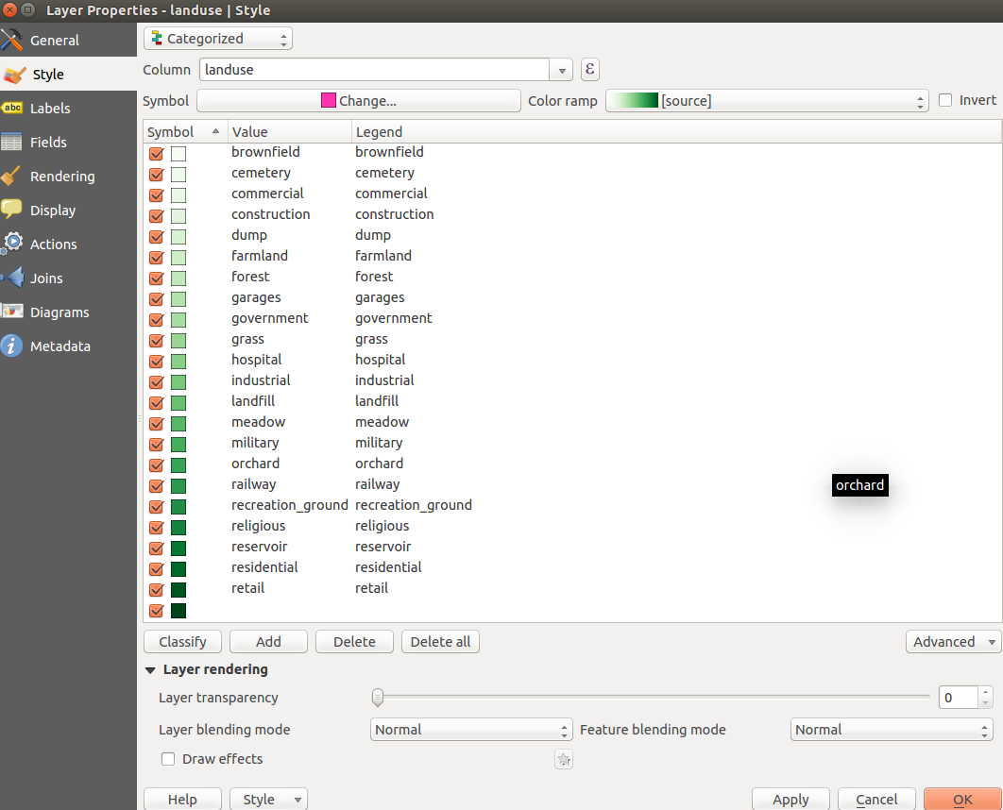

* Click *OK*.

You’ll see something like this:

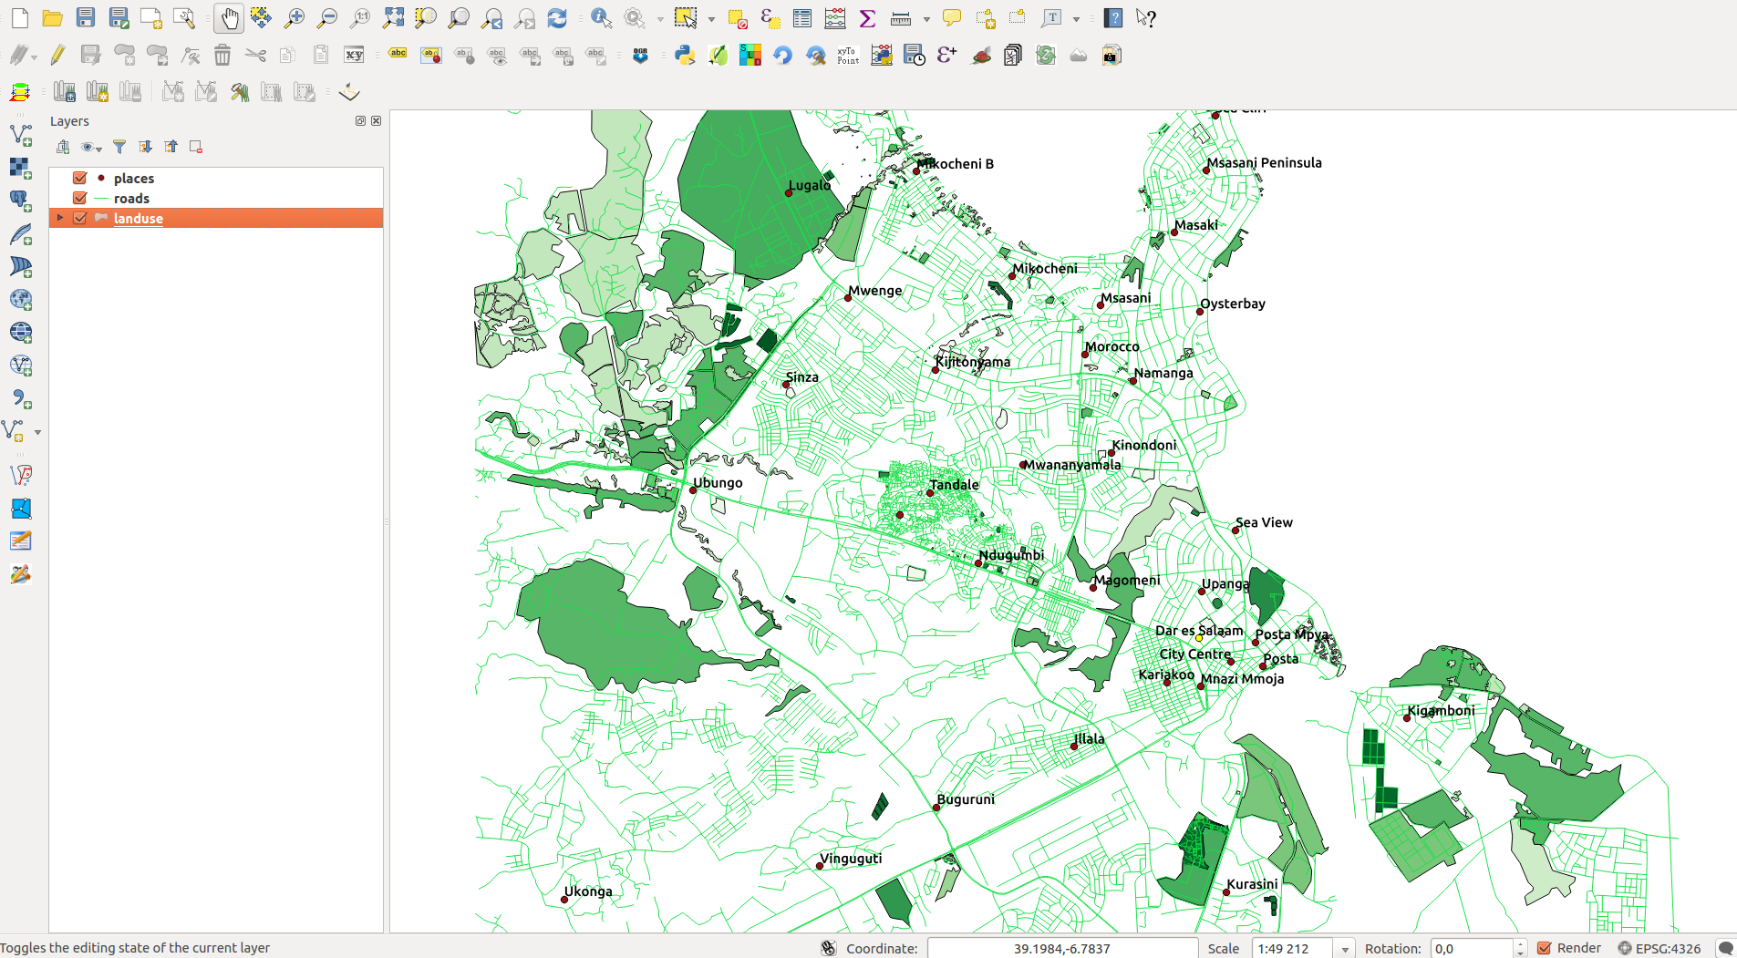

* Click the arrow (or plus sign) next to *landuse* in the *Layer list*, you’ll see the categories explained:

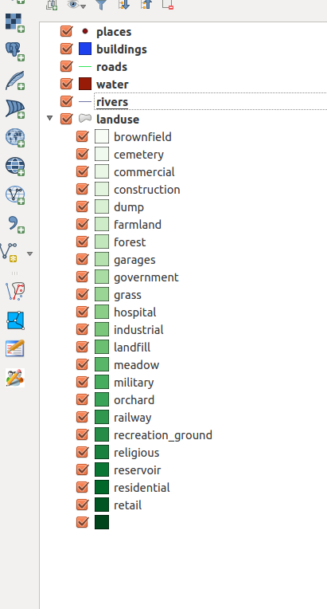

Now our landuse polygons are appropriately colored and are classified so that areas with the same land use are the same color. You may wish to remove the black border from the *landuse* layer:

* Open *Layer Properties*, go to the *Style* tab and select *Symbol*.
* Change the symbol by removing the border from the *Simple Fill* layer and click *OK*.

You’ll see that the landuse polygon outlines have been removed, leaving just our new fill colours for each categorisation.

* If you wish to, you can change the fill color for each landuse area by double-clicking the relevant color block:

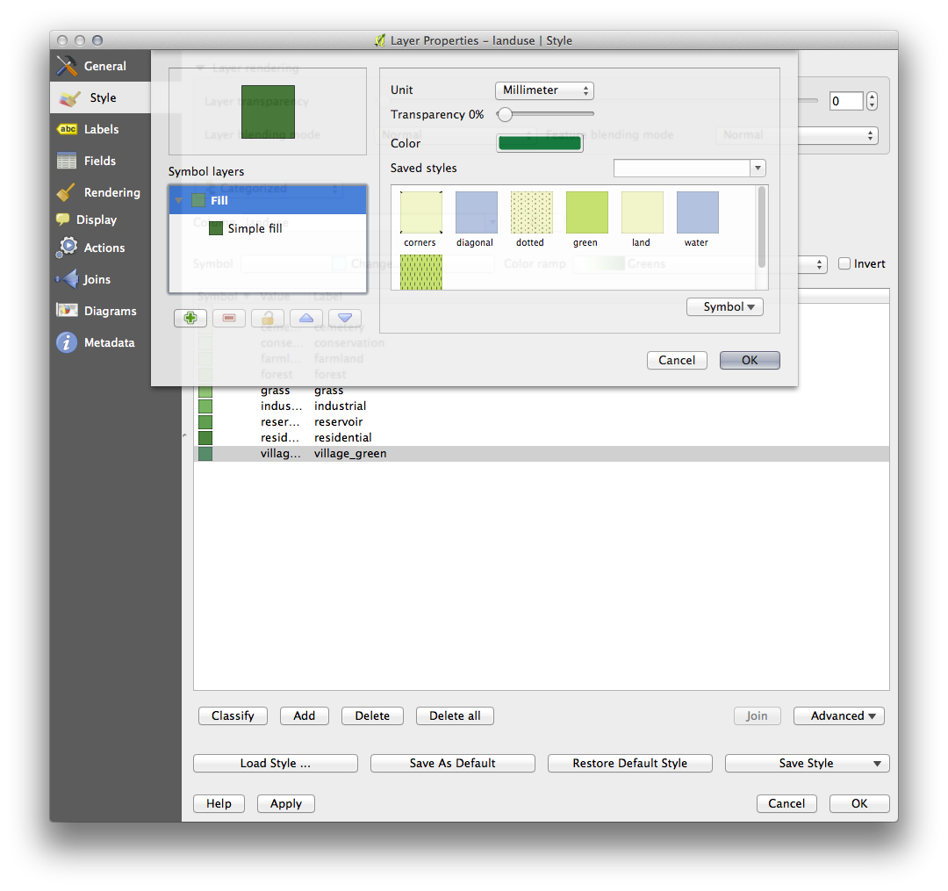

Notice that there is one category that’s empty:

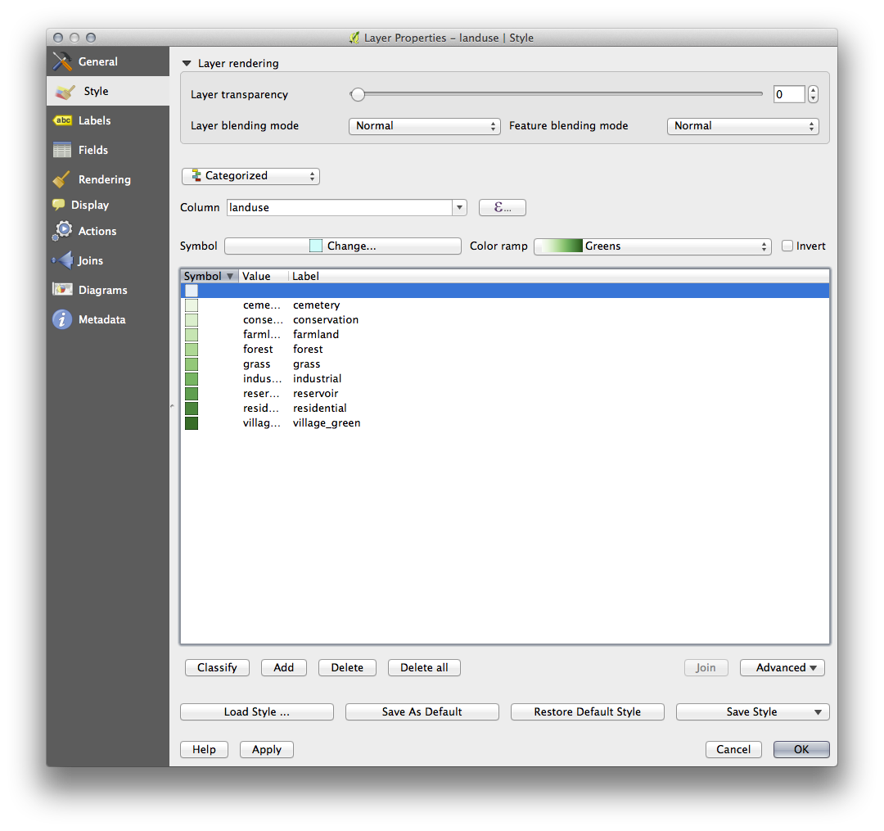

This empty category is used to color any objects which do not have a landuse value defined or which have a *NULL* value. It is important to keep this empty category so that areas with a *NULL* value are still represented on the map. You may like to change the color to more obviously represent a blank or *NULL* value.

Remember to save your map now so that you don’t lose all your hard-earned changes!

## 2.3.2. basic Try Yourself More Classification

If you’re only following the basic-level content, use the knowledge you gained above to classify the *buildings* layer. Set the categorisation against the *building* column and use the *Spectral* color ramp.

Note

Remember to zoom into an urban area to see the results.

## 2.3.3. moderate Follow Along: Ratio Classification

There are four types of classification: *nominal*, *ordinal*, *interval* and *ratio*.

In nominal classification, the categories that objects are classified into are name-based; they have no order. For example: town names, district codes, etc.

In ordinal classification, the categories are arranged in a certain order. For example, world cities are given a rank depending on their importance for world trade, travel, culture, etc.

In interval classification, the numbers are on a scale with positive, negative and zero values. For example: height above/below sea level, temperature above/below freezing (0 degrees Celsius), etc.

In ratio classification, the numbers are on a scale with only positive and zero values. For example: temperature above absolute zero (0 degrees Kelvin), distance from a point, the average amount of traffic on a given street per month, etc.

In the example above, we used nominal classification to assign each farm to the town that it is administered by. Now we will use ratio classification to classify the farms by area.

* Save your landuse symbology (if you want to keep it) by clicking on the *Save Style ...* button in the *Style* dialog.

We’re going to reclassify the layer, so existing classes will be lost if not saved.

* Close the *Style* dialog.
* Open the Attributes Table for the *landuse* layer.

We want to classify the landuse areas by size, but there’s a problem: they don’t have a size field, so we’ll have to make one.

* Enter edit mode by clicking this button:



* Add a new column with this button:



* Set up the dialog that appears, like this:

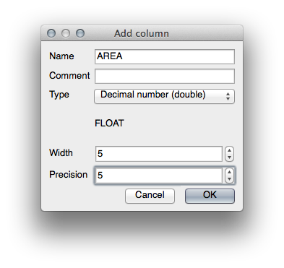

* Click *OK*.

The new field will be added (at the far right of the table; you may need to scroll horizontally to see it). However, at the moment it is not populated, it just has a lot of NULL values.

To solve this problem, we’ll need to calculate the areas.

* Open the field calculator:



You’ll get this dialog:

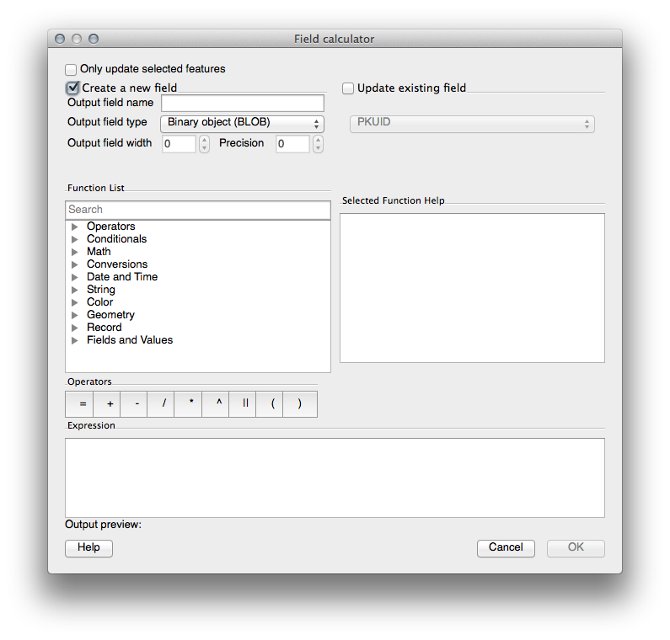

* Change the values at the top of the dialog to look like this:

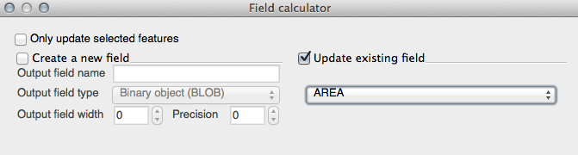

* In the *Function List*, select *Geometry ‣ $area*:

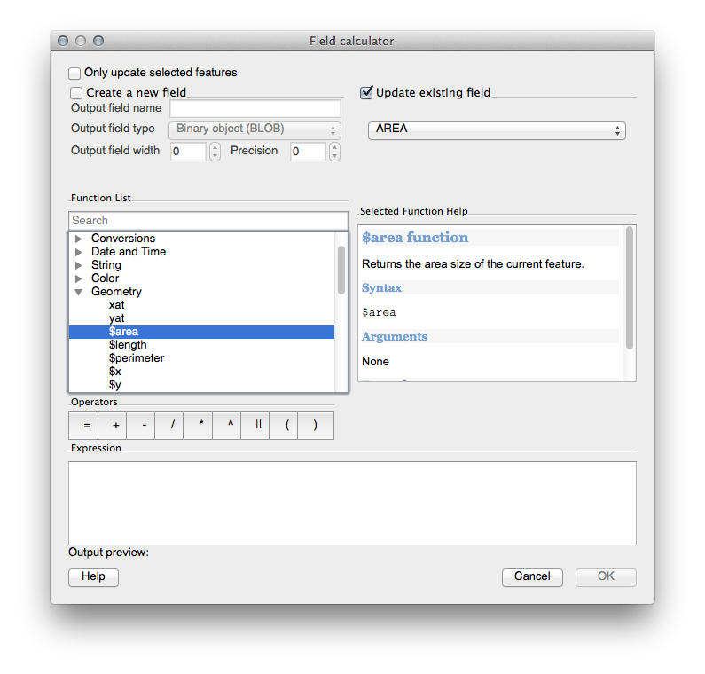

* Double-click on it so that it appears in the *Expression* field.
* Click *OK*.

Now your AREA field is populated with values (you may need to click the column header to refresh the data). Save the edits and click *Ok*.

Note

These areas are in degrees. Later, we will compute them in square meters.

* Open the *Layer properties* dialog’s *Style* tab.
* Change the classification style from *Categorized* to *Graduated*.
* Change the *Column* to *AREA*:
* Under *Color ramp*, choose the option *New color ramp...* to get this dialog:

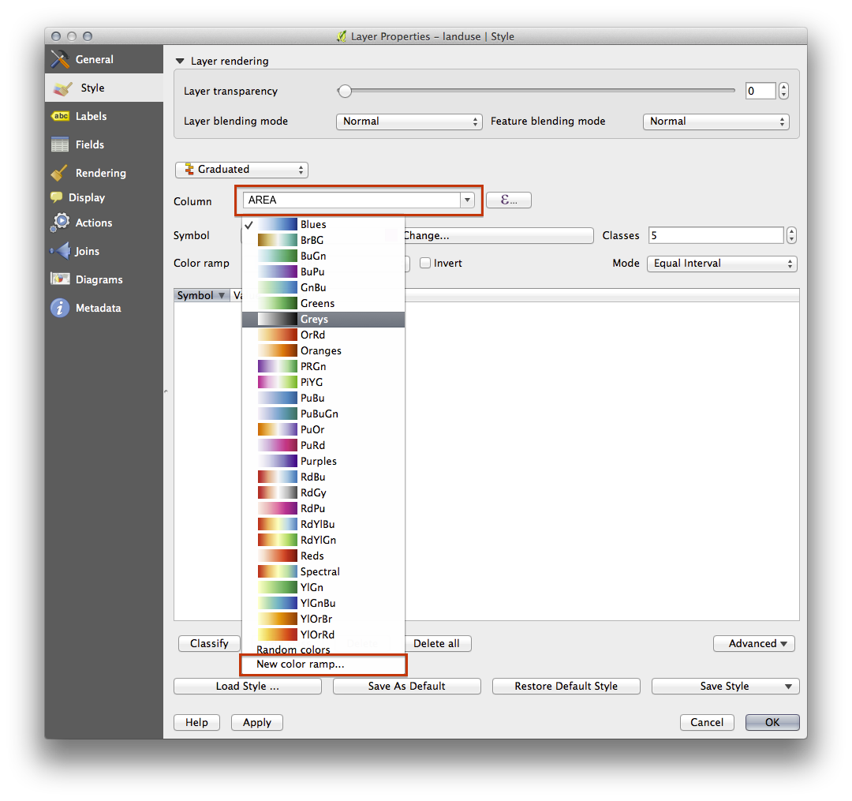

* Choose *Gradient* (if it’s not selected already) and click *OK*. You’ll see this:

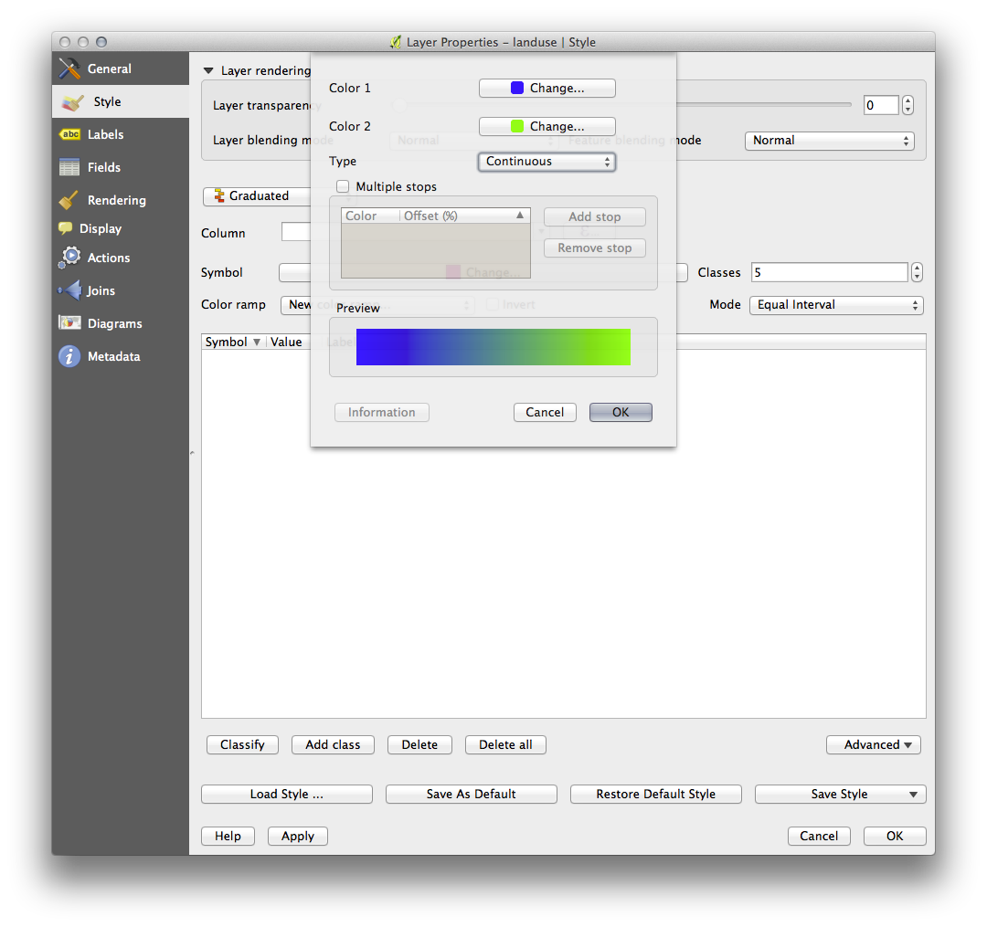

You’ll be using this to denote area, with small areas as *Color 1* and large areas as *Color 2*.

* Choose appropriate colors.

In the example, the result looks like this:

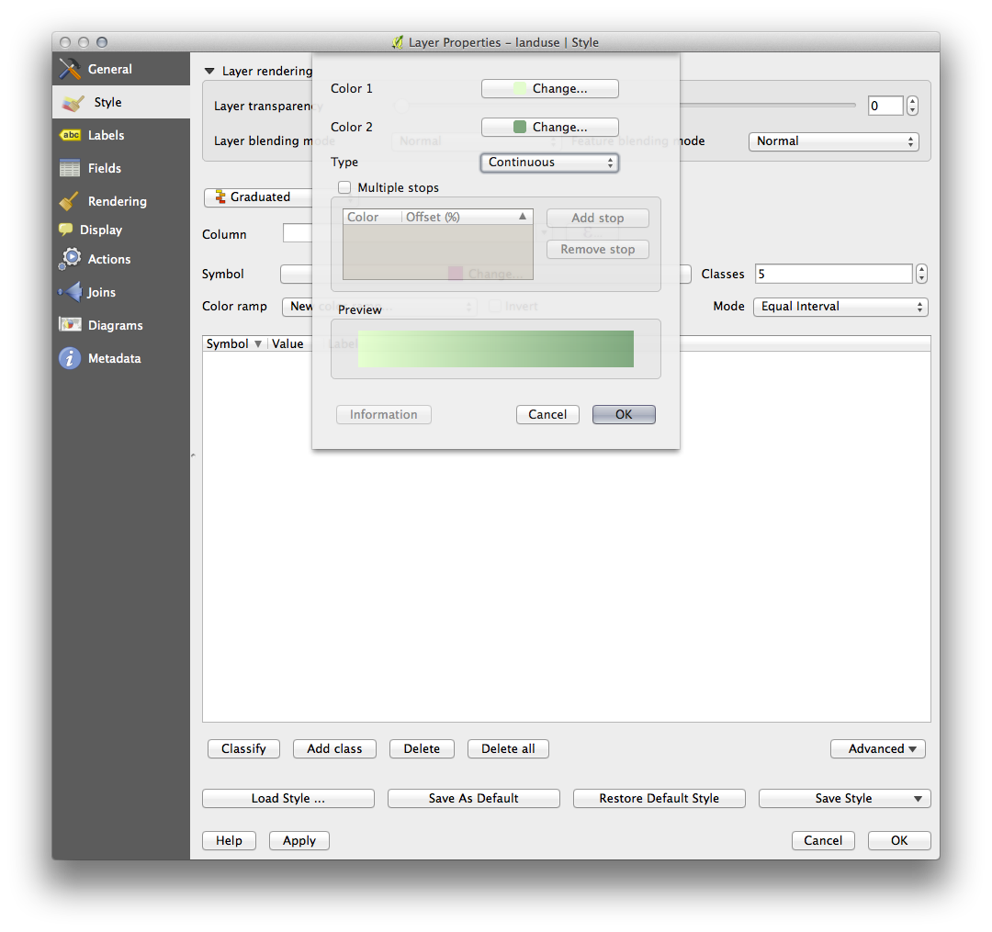

* Click *OK*.
* Choose a suitable name for the new color ramp.
* Click *OK* after filling in the name.

Now you’ll have something like this:

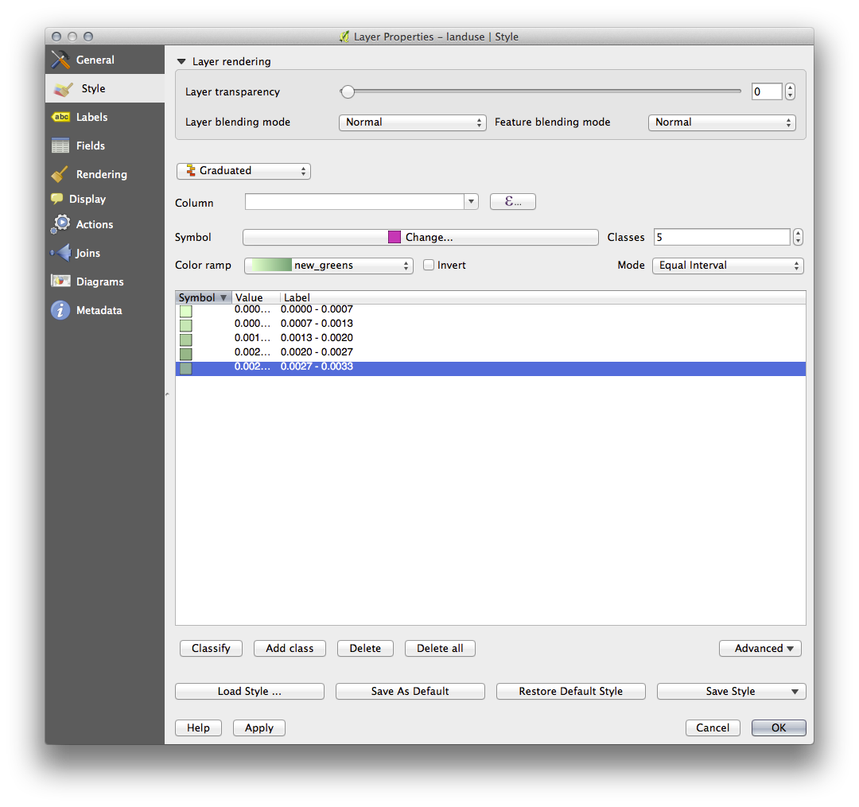

Leave everything else as-is.

* Click *Ok*:

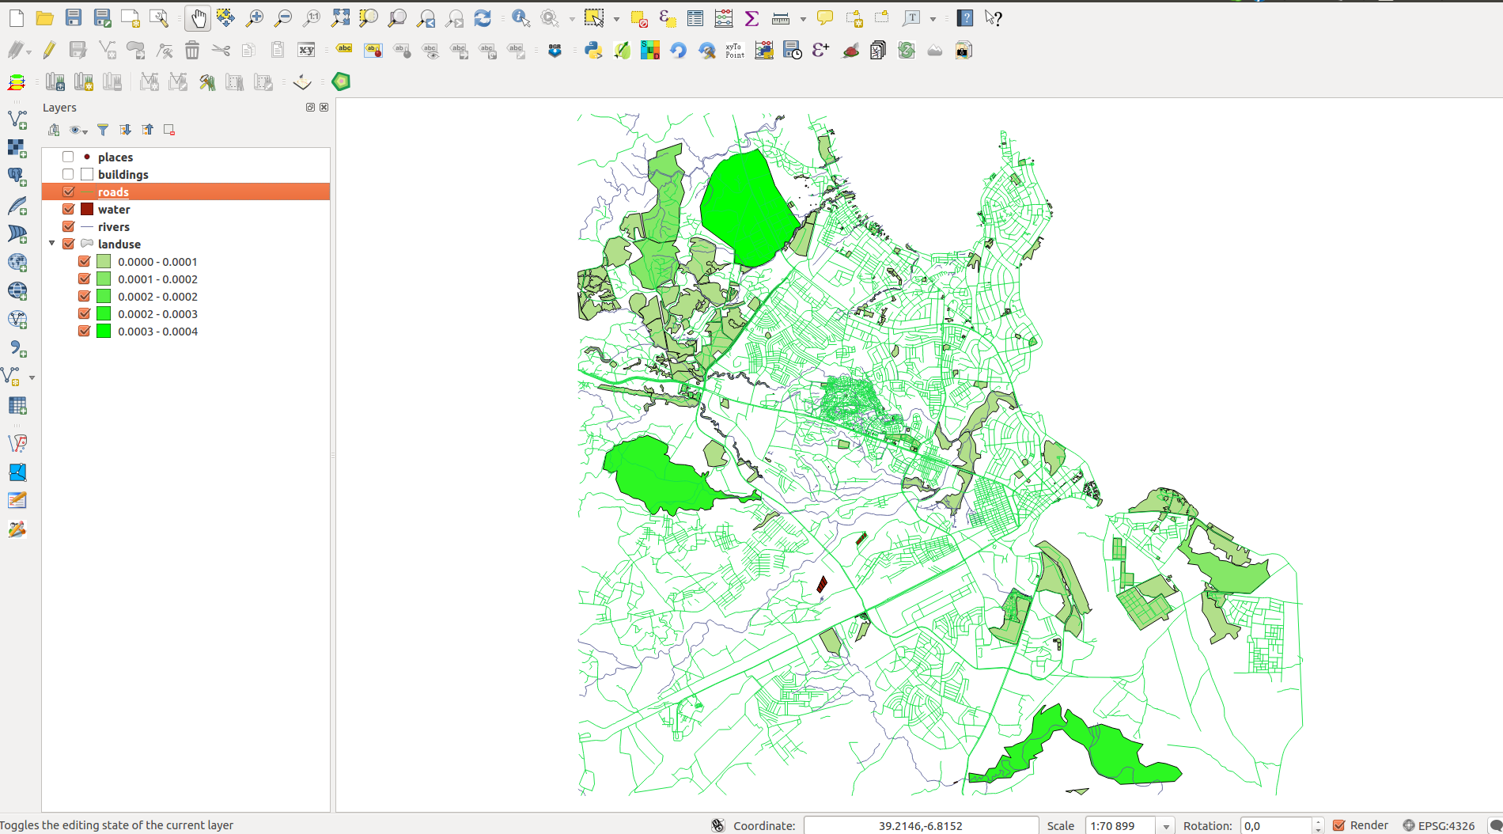

## 2.3.4. moderate Try Yourself Refine the Classification

* Get rid of the lines between the classes.
* Change the values of *Mode* and *Classes* until you get a classification that makes sense.

## 2.3.5. In Conclusion

Symbology allows us to represent the attributes of a layer in an easy-to-read way. It allows us as well as the map reader to understand the significance of features, using any relevant attributes that we choose. Depending on the problems you face, you’ll apply different classification techniques to solve them.

## 

# 

## 3.1. Lesson: Creating a New Vector Dataset

The data that you use has to come from somewhere. For most common applications, the data exists already; but the more particular and specialized the project, the less likely it is that the data will already be available. In such cases, you’ll need to create your own new data.

## 3.1.1. basic Follow Along: The Layer Creation Dialog

**The goal for this lesson:** To create a new vector dataset.

Before you can add new vector data, you need a vector dataset to add it to. In our case, you’ll begin by creating new data entirely, rather than editing an existing dataset. Therefore, you’ll need to define your own new dataset first.

You’ll need to open the *New Vector Layer* dialog that will allow you to define a new layer.

* Navigate to and click on the menu entry *Layer ‣ New ‣ New Shapefile Layer*.

You’ll be presented with the following dialog:

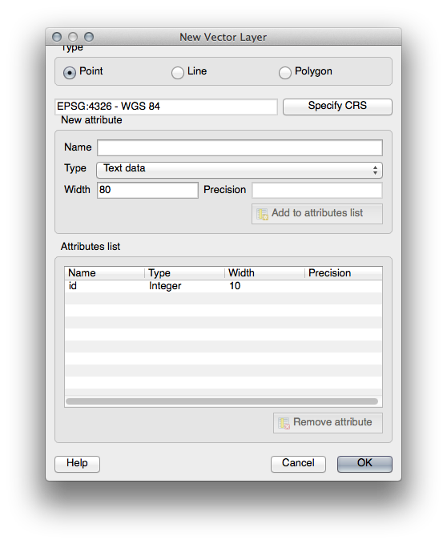

It’s important to decide which kind of dataset you want at this stage. Each different vector layer type is “built differently” in the background, so once you’ve created the layer, you can’t change its type.

For the next exercise, we’re going to be creating new features which describe areas. For such features, you’ll need to create a polygon dataset.

* Click on the *Polygon* radio button:

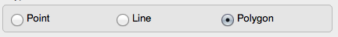

This has no impact on the rest of the dialog, but it will cause the correct type of geometry to be used when the vector dataset is created.

The next field allows you to specify the Coordinate Reference System, or CRS. A CRS specifies how to describe a point on Earth in terms of coordinates, and because there are many different ways to do this, there are many different CRSs. The CRS of this project is WGS84, so it’s already correct by default:



Next there is a collection of fields grouped under *New attribute*. By default, a new layer has only one attribute, the id field (which you should see in the *Attributes list*) below. However, in order for the data you create to be useful, you actually need to say something about the features you’ll be creating in this new layer. For our current purposes, it will be enough to add one field called name.

* Replicate the setup below, then click the *Add to attributes list* button:

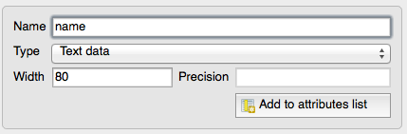

* Check that your dialog now looks like this:

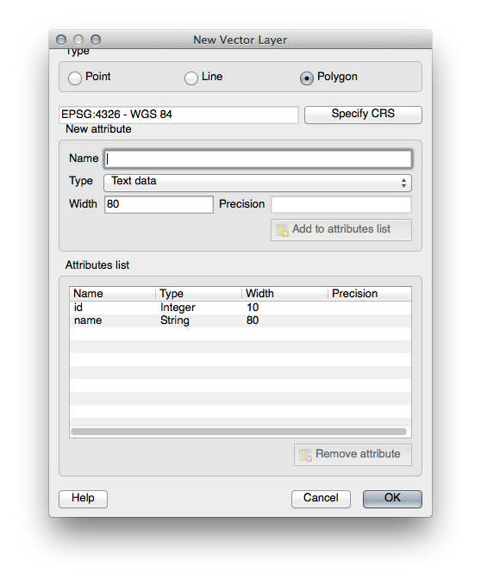

* Click *OK*. A save dialog will appear.
* Navigate to the exercise\_data directory.
* Save your new layer as residential\_property.shp.

The new layer should appear in your *Layers list*.

## 3.1.2. basic Follow Along: Data Sources

When you create new data, it obviously has to be about objects that really exist on the ground. Therefore, you’ll need to get your information from somewhere.

There are many different ways to obtain data about objects. For example, you could use a GPS to capture points in the real world, then import the data into QGIS afterwards. Or you could survey points using a theodolite, and enter the coordinates manually to create new features. Or you could use the digitizing process to trace objects from remote sensing data, such as satellite imagery or aerial photography.

For our example, you’ll be using the digitizing approach. Sample raster datasets are provided, so you’ll need to import them as necessary.

* Click on the *Add Raster Layer* button:
* Navigate to exercise\_data/raster/.
* Select the file tandale\_imagery.tif.
* Click *Open*. An image will load into your map.
* Find the new image in the *Layers list*.
* Click and drag it to the bottom of the list so that you can still see your other layers.
* Find and zoom to this area:

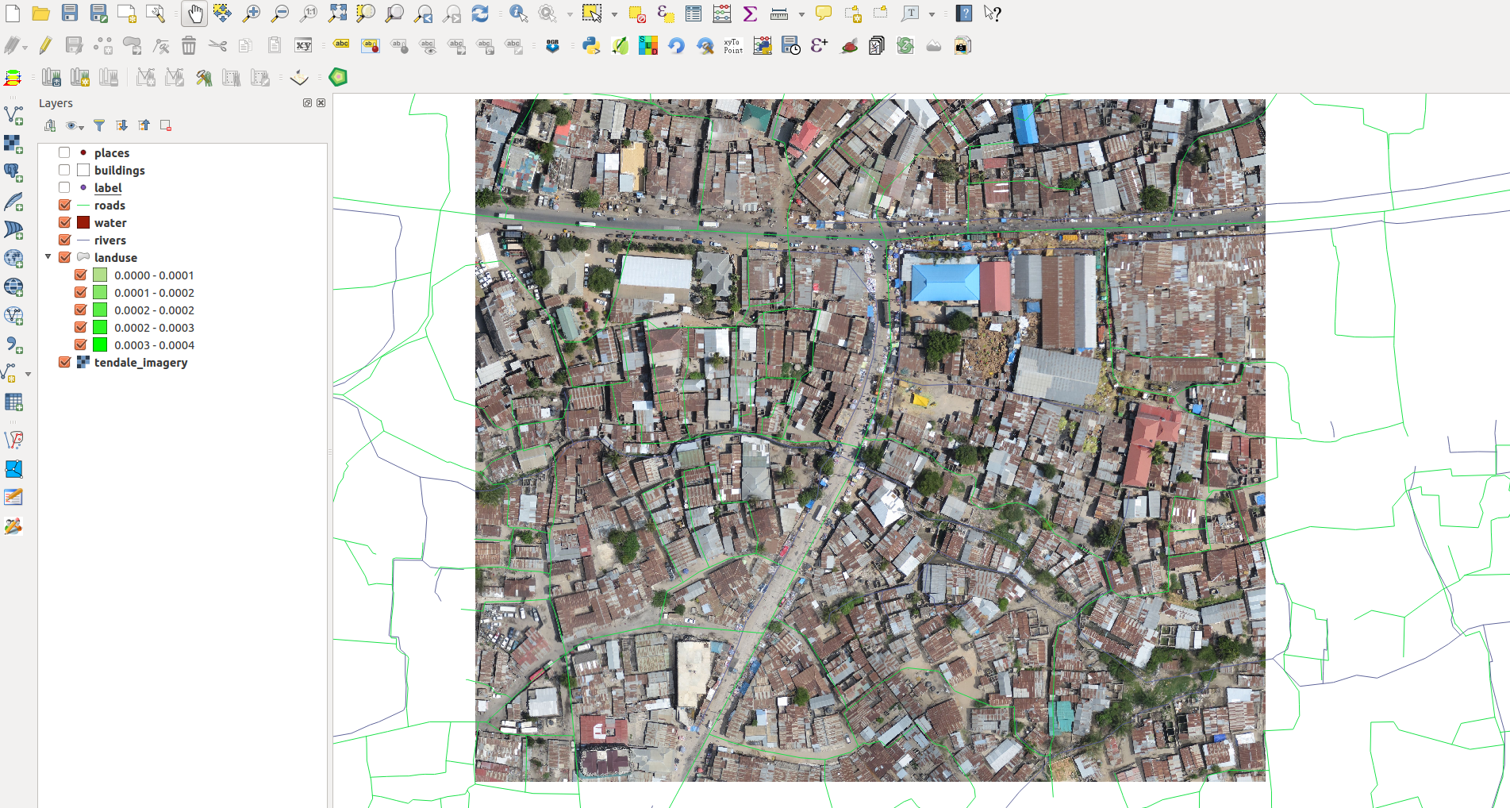

Note

If your *buildings* layer symbology is covering part or all of the raster layer, you can temporarily disable the layer by deselecting it in the *Layers panel*. You may also wish to hide the *roads* symbology if you find it distracting.

You’ll be digitizing these three features:

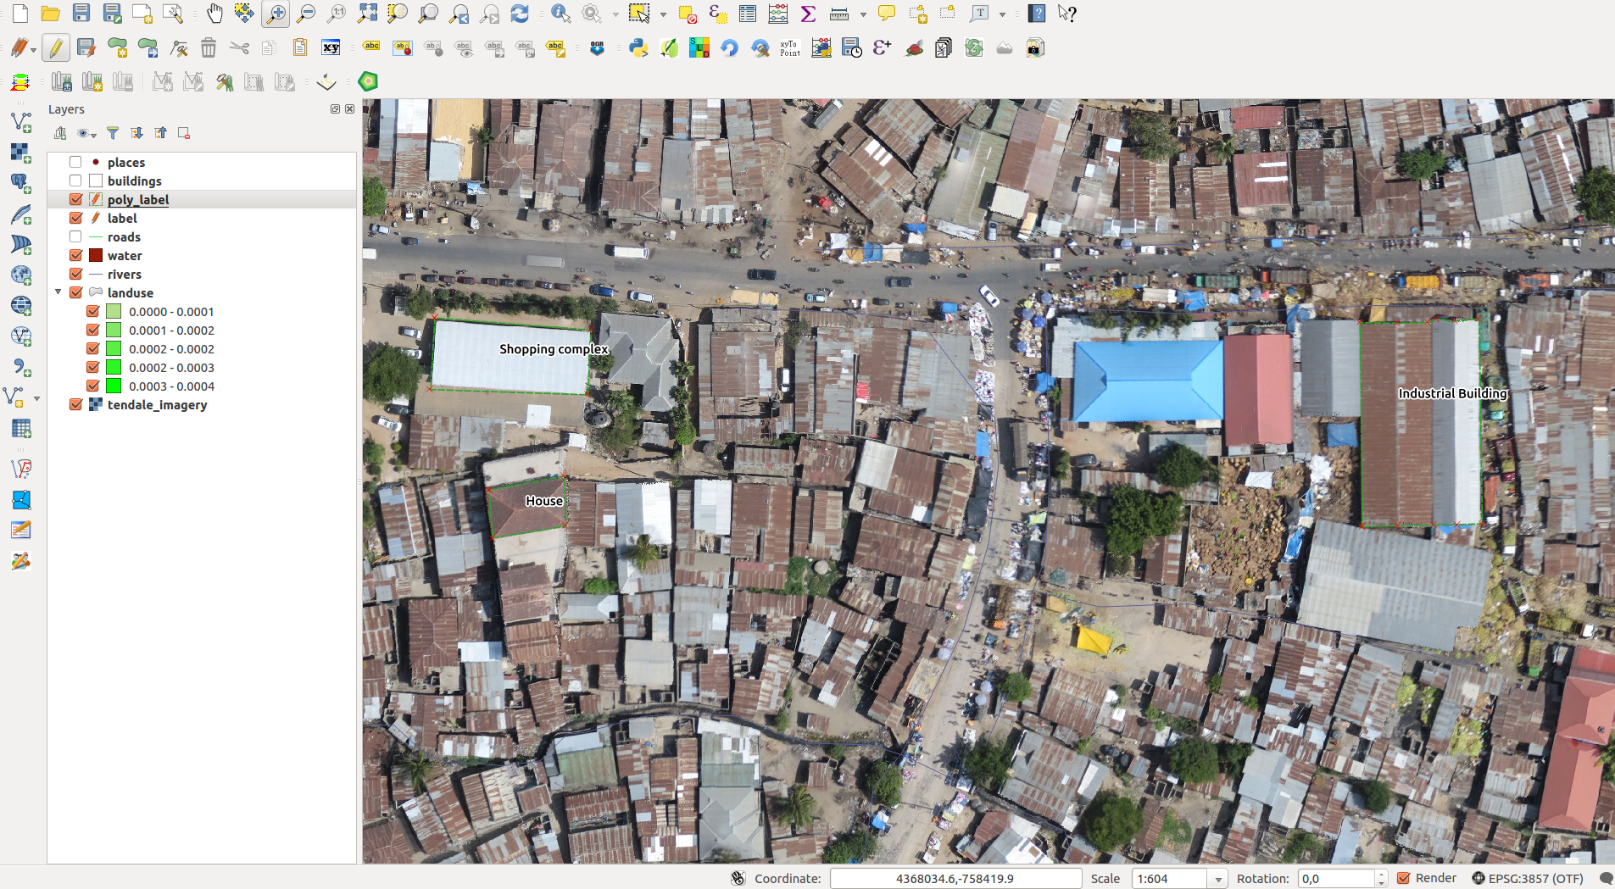

In order to begin digitizing, you’ll need to enter **edit mode**. GIS software commonly requires this to prevent you from accidentally editing or deleting important data. Edit mode is switched on or off individually for each layer.

To enter edit mode for the *residential\_property* layer:

* Click on the layer in the *Layer list* to select it. (Make very sure that the correct layer is selected, otherwise you’ll edit the wrong layer!)
* Click on the *Toggle Editing* button:

If you can’t find this button, check that the *Digitizing* toolbar is enabled. There should be a check mark next to the *View ‣ Toolbars ‣ Digitizing* menu entry.

As soon as you are in edit mode, you’ll see the digitizing tools are now active:



Four other relevant buttons are still inactive, but will become active when we start interacting with our new data:



From left to right on the toolbar, they are:

* *Save Edits*: saves changes made to the layer.
* *Add Feature*: start digitizing a new feature.
* *Move Feature(s)*: move an entire feature around.
* *Node Tool*: move only one part of a feature.
* *Delete Selected*: delete the selected feature.
* *Cut Features*: cut the selected feature.
* *Copy Features*: copy the selected feature.
* *Paste Features*: paste a cut or copied feature back into the map.

You want to add a new feature.

* Click on the *Add Feature* button now to begin digitizing our school fields.

You’ll notice that your mouse cursor has become a crosshair. This allows you to more accurately place the points you’ll be digitizing. Remember that even as you’re using the digitizing tool, you can zoom in and out on your map by rolling the mouse wheel, and you can pan around by holding down the mouse wheel and dragging around in the map.

The first feature you’ll be digitizing is the shopping complex:

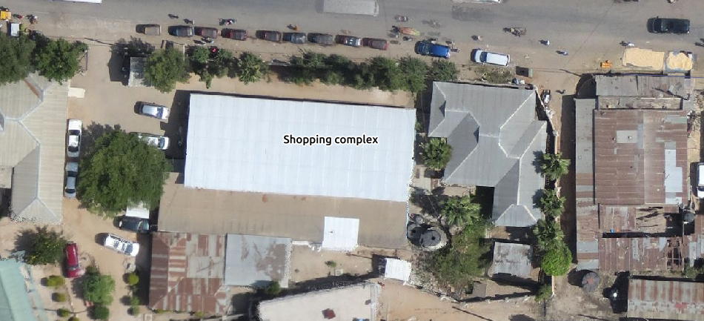

* Start digitizing by clicking on a point somewhere along the edge of the building.
* Place more points by clicking further along the edge, until the shape you’re drawing completely covers the field.
* After placing your last point, *right-click* to finish drawing the polygon. This will finalize the feature and show you the *Attributes* dialog.
* Fill in the values as below:

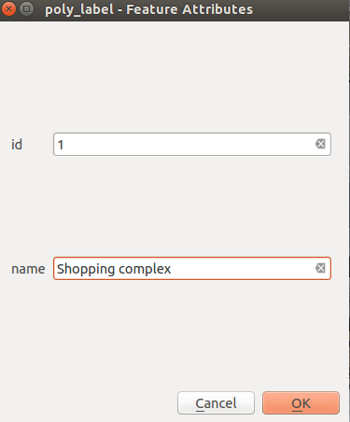

* Click *OK* and you’ve created a new feature!

Remember, if you’ve made a mistake while digitizing a feature, you can always edit it after you’re done creating it. If you’ve made a mistake, continue digitizing until you’re done creating the feature as above. Then:

* Select the feature with the *Select Single Feature* tool:

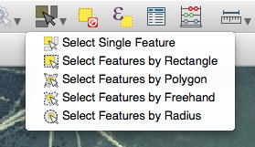

You can use:

* the *Move Feature(s)* tool to move the entire feature,
* the *Node Tool* to move only one point where you may have miss-clicked,
* *Delete Selected* to get rid of the feature entirely so you can try again, and
* the *Edit ‣ Undo* menu item or the ctrl + z keyboard shortcut to undo mistakes.

## 3.1.3. basic Try Yourself

* Digitize the house itself and the industrial building. Use this image to assist you:

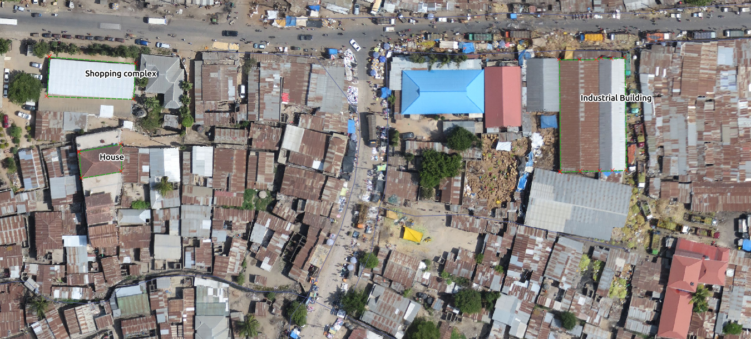

Remember that each new feature needs to have a unique id value!

Note

When you’re done adding features to a layer, remember to save your edits and then exit edit mode.

Note

You can style the fill, outline and label placement and formatting of the *school\_property* using techniques learnt in earlier lessons. In our example, we will use a dashed outline of light purple color with no fill.

## 3.1.4. basic Try Yourself

* Create a new line feature called routes.shp with attributes id and type. (Use the approach above to guide you.)
* We’re going to digitize two routes ; one is a main road, the other is a track or street road.

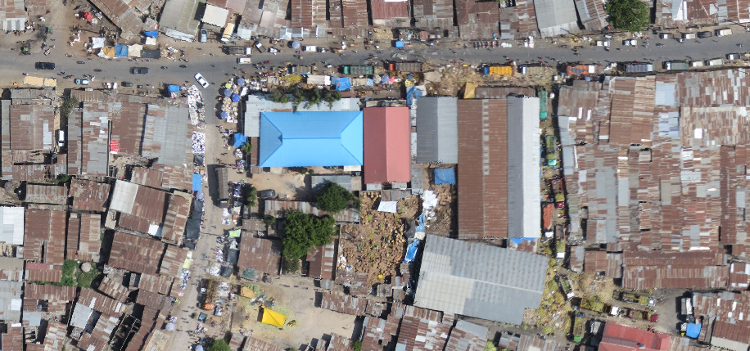

One at a time, digitize the path and the track on the *routes* layer. Try to follow the routes as accurately as possible, using points (left-click) at any corners or turns.

When creating each route, give them the type attribute value of path or track.

You’ll probably find that only the points are marked; use the *Layer Properties* dialog to add styling to your routes. Feel free to give different styles to the path and track.

Save your edits and toggle *Edit* mode.

## 3.1.5. In Conclusion

Now you know how to create features! This course doesn’t cover adding point features, because that’s not really necessary once you’ve worked with more complicated features (lines and polygons). It works exactly the same, except that you only click once where you want the point to be, give it attributes as usual, and then the feature is created.

Knowing how to digitize is important because it’s a very common activity in GIS programs.

# 3.2. Lesson: Feature Topology

Topology is a useful aspect of vector data layers, because it minimizes errors such as overlap or gaps.

For example: if two features share a border, and you edit the border using topology, then you won’t need to edit first one feature, then another, and carefully line up the borders so that they match. Instead, you can edit their shared border and both features will change at the same time.

**The goal for this lesson:** To understand topology using examples.

## 3.2.1. moderate Follow Along: Snapping

To make topological editing easier, it’s best if you enable snapping. This will allow your mouse cursor to snap to other objects while you digitize. To set snapping options:

* Navigate to the menu entry *Settings ‣ Snapping Options...*.
* Set up your *Snapping options* dialog as shown:

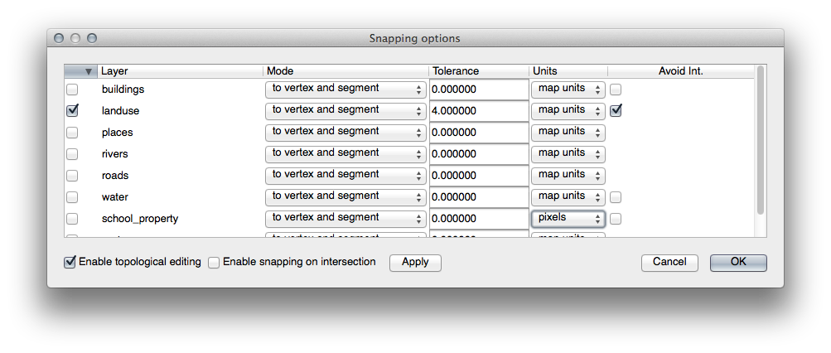

* Ensure that the box in the *Avoid Int.* column is checked (set to true).
* Click *OK* to save your changes and leave the dialog.
* Enter edit mode with the *landuse* layer selected.
* Check under *View ‣ Toolbars* to make sure that your *Advanced Digitizing* toolbar is enabled.
* Zoom to this area (enable layers and labels if necessary:

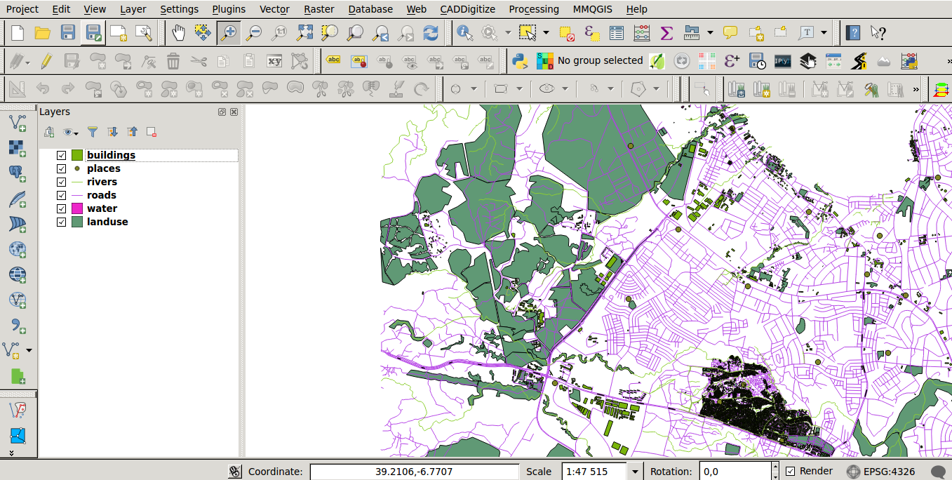

* Digitize this new (fictional) area of the Lugalo Military Base:

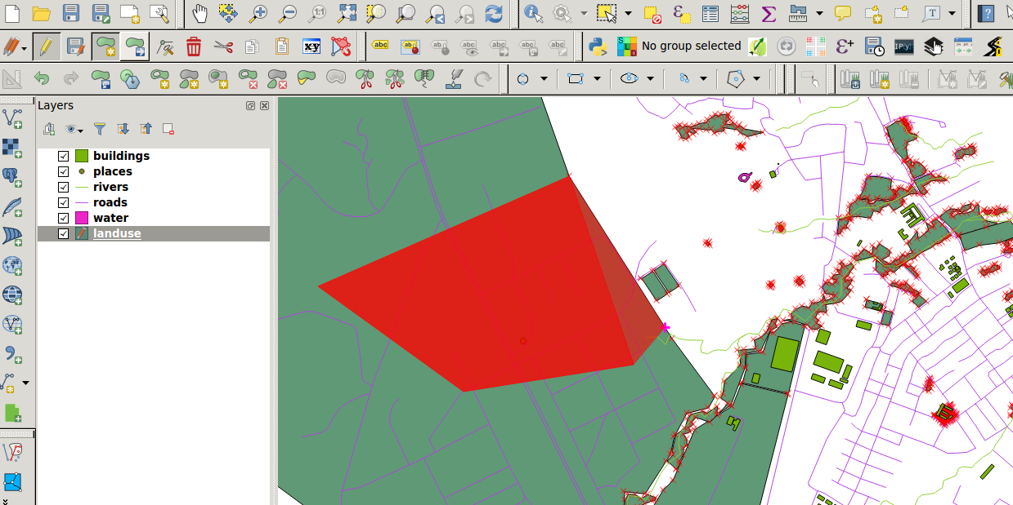

* When prompted, give it a *OGC\_FID* of 999, but feel free to leave the other values unchanged.

If you’re careful while digitizing and allow the cursor to snap to the vertices of adjoining farms, you’ll notice that there won’t be any gaps between your new farm and the existing farms adjacent to it.

* Note the undo/redo tools in the *Advanced Digitizing* toolbar:
* 

## 3.2.2. moderate Follow Along: Correct Topological Features

Topology features can sometimes need to be updated. In our example, the *landuse* layer has some complex forest areas which have recently been joined to form one area:

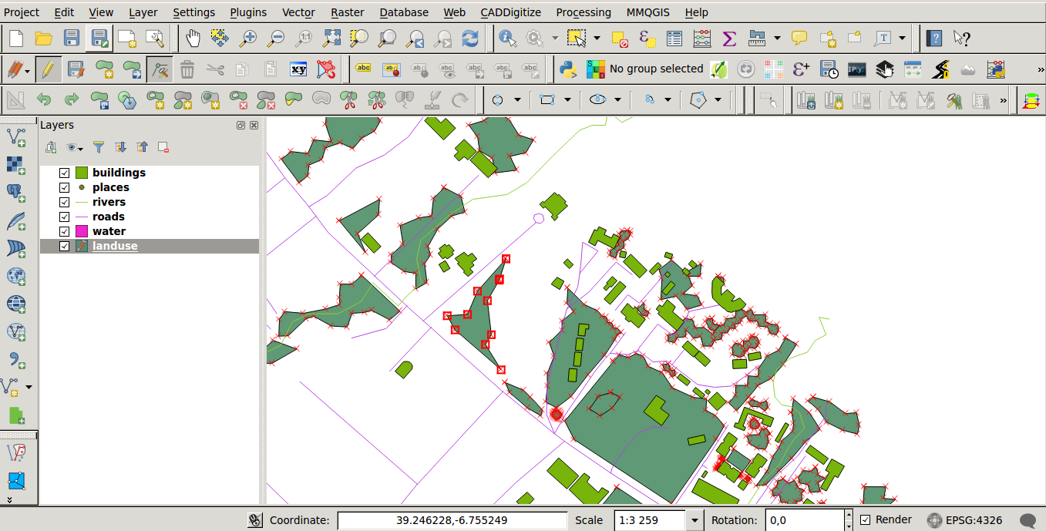

Instead of creating new polygons to join the forest areas, we’re going to use the *Node Tool* to edit the existing polygons and join them.

* Enter edit mode, if it isn’t active already.
* Select the *Node Tool*.
* Pick an area of forest, select a corner and move it to an adjoining corner so two forest sections meet:
* Click and drag the nodes until they snap into place.

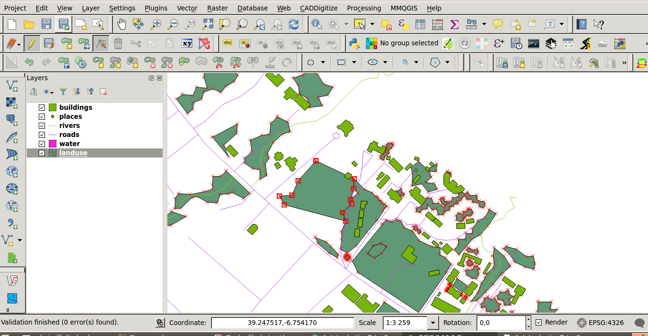

Go ahead and join a few more areas using the *Node Tool*. You can also use the *Add Feature* tool if it is appropriate. If you are using our example data, you should have a forest area looking something like this:

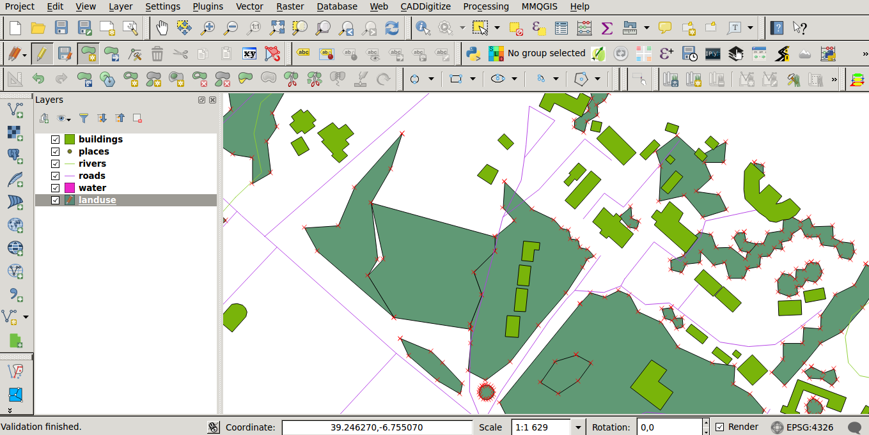

Don’t worry if you have joined more, less or different areas of forest.

## 3.2.3. In Conclusion

Topology editing is a powerful tool that allows you to create and modify objects quickly and easily, while ensuring that they remain topologically correct.

# 4.1. Lesson: Working with Raster Data

Raster data is quite different from vector data. Vector data has discrete features constructed out of vertices, and perhaps connected with lines and/or areas. Raster data, however, is like any image. Although it may portray various properties of objects in the real world, these objects don’t exist as separate objects; rather, they are represented using pixels of various different color values.

During this module you’re going to use raster data to supplement your existing GIS analysis.

**The goal for this lesson:** To learn how to work with raster data in the QGIS environment.

There we have it - four aerial photographs covering our whole study area.

# 4.1. Lesson: Changing Raster Symbology

Not all raster data consists of aerial photographs. There are many other forms of raster data, and in many of those cases, it’s essential to symbolize the data properly so that it becomes properly visible and useful.

**The goal for this lesson:** To change the symbology for a raster layer.

## 4.1.1. basic Try Yourself

* Start with the current map which you should have created during the previous exercise: analysis.qgs.
* Use the *Add Raster Layer* button to load the new raster dataset.
* Load the dataset srtm.tif, found under the directory exercise\_data/raster/SRTM/.
* Once it appears in the *Layers list*, rename it to DEM.
* Zoom to the extent of this layer by right-clicking on it in the Layer List and selecting *Zoom to Layer Extent*.

This dataset is a *Digital Elevation Model (DEM)*. It’s a map of the elevation (altitude) of the terrain, allowing us to see where the mountains and valleys are, for example.

Once it’s loaded, you’ll notice that it’s a basic stretched grayscale representation of the DEM. It’s seen here with the vector layers on top:

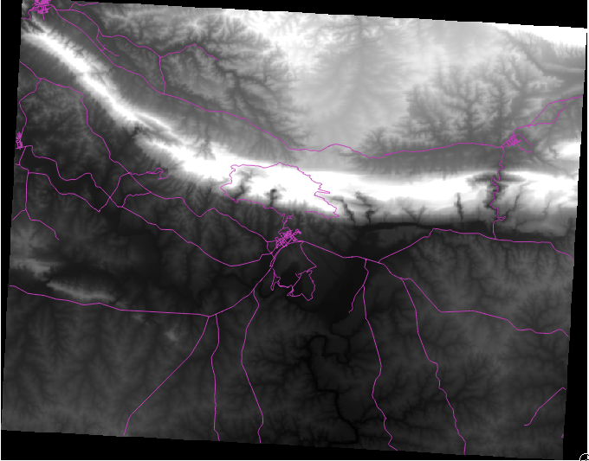

QGIS has automatically applied a stretch to the image for visualization purposes, and we will learn more about how this works as we continue.

## 4.1.2. basic Follow Along: Changing Raster Layer Symbology

* Open the *Layer Properties* dialog for the *SRTM* layer by right-clicking on the layer in the Layer tree and selecting *Properties* option.
* Switch to the *Style* tab.

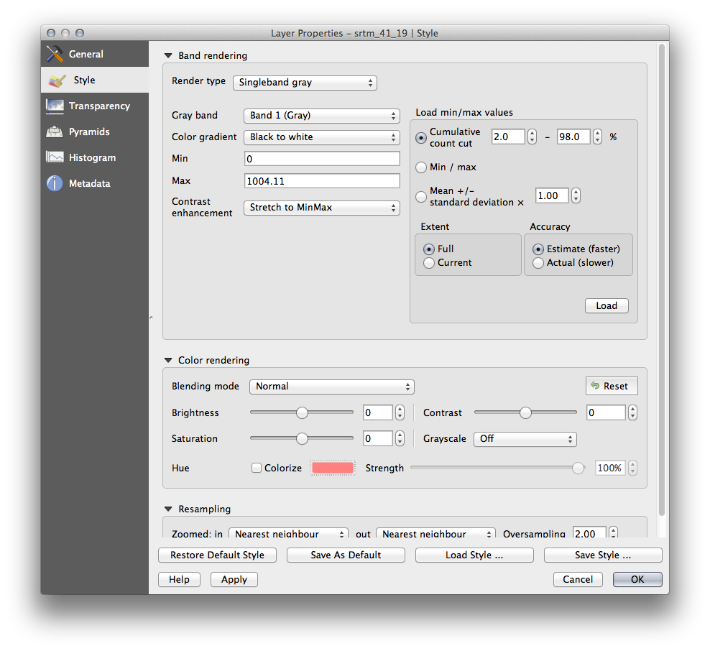

These are the current settings that QGIS applied for us by default. Its just one way to look at a DEM, so lets explore some others.

* Change the *Render type* to *Singleband pseudocolor*, and use the default options presented.
* Click the *Classify* button to generate a new color classification, and click *OK* to apply this classification to the DEM.

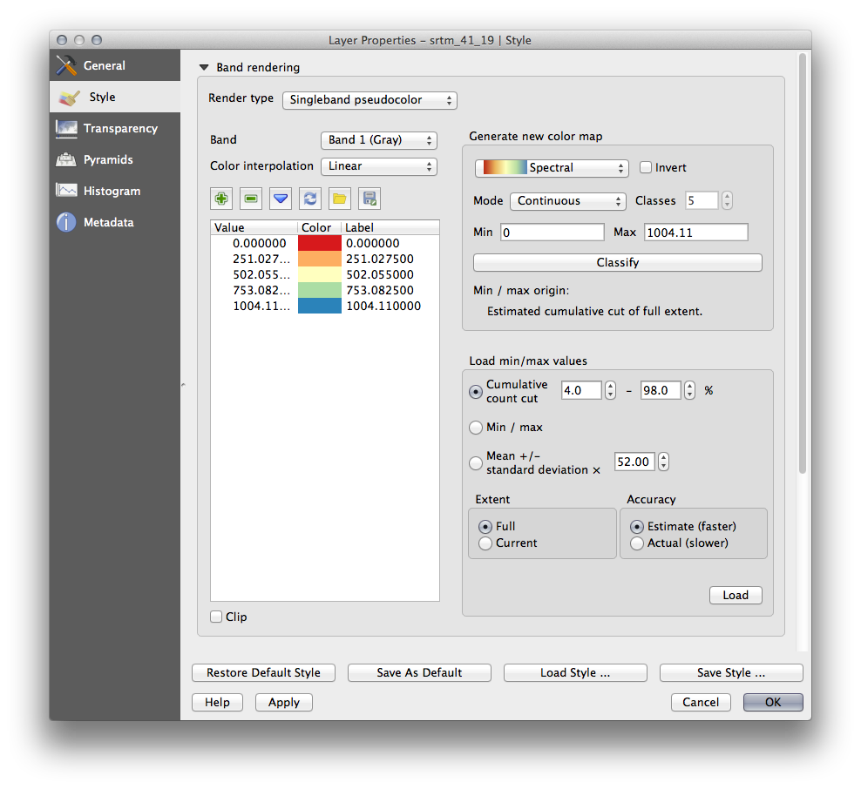

You’ll see the raster looking like this:

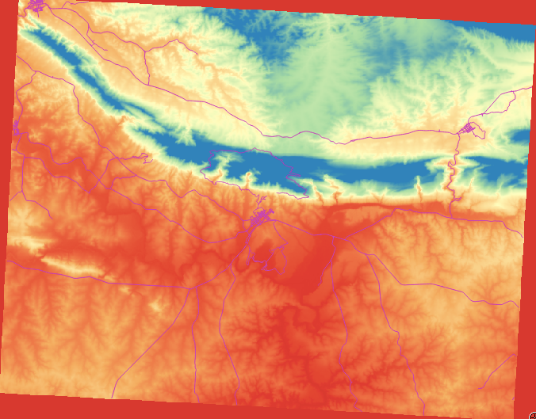

This is an interesting way of looking at the DEM, but maybe we don’t want to symbolize it using these colors.

* Open *Layer Properties* dialog again.
* Switch the *Render Type* back to *Singleband gray*.
* Click *OK* to apply this setting to the raster.

You will now see a totally gray rectangle that isn’t very useful at all.

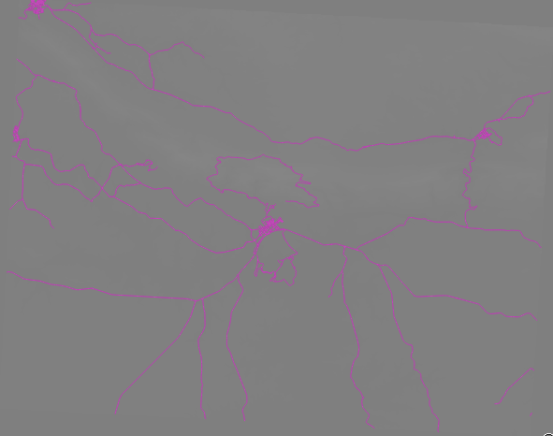

This is because we have lost the default settings which “stretch” the color values to show them contrast.

Let’s tell QGIS to again “stretch” the color values based on the range of data in the DEM. This will make QGIS use all of the available colors (in *Grayscale*, this is black, white and all shades of gray in between).

* Specify the *Min* and *Max* values as shown below.
* Set the value *Contrast enhancement* to *Stretch To MinMax*:

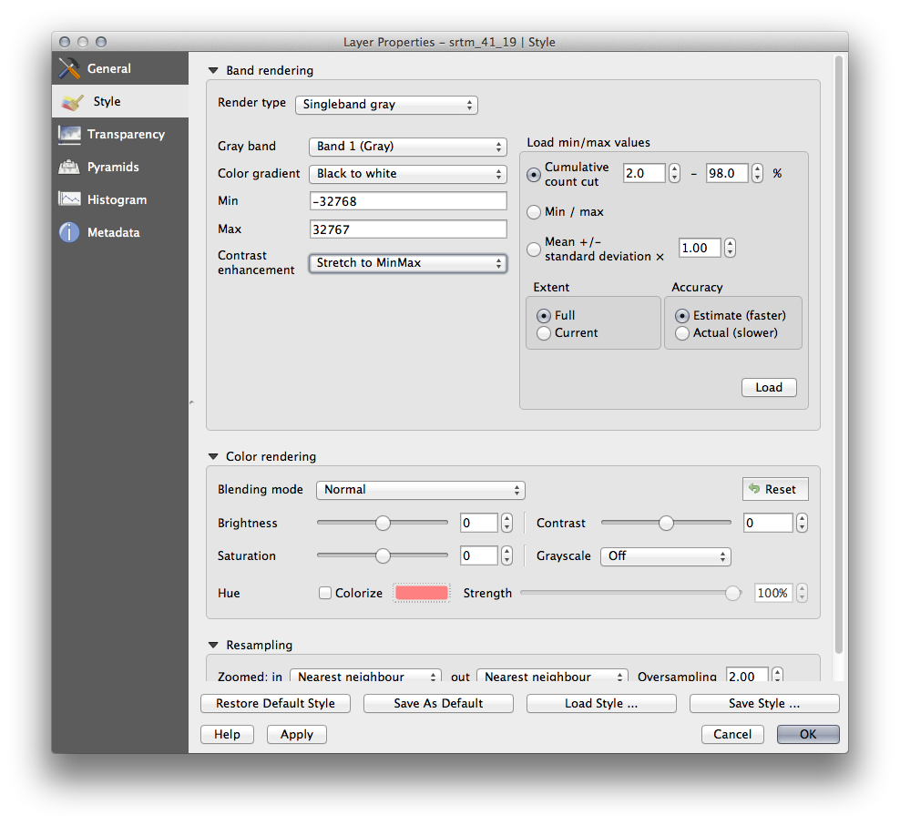

But what are the minimum and maximum values that should be used for the stretch? The ones that are currently under *Min* and *Max* values are the same values that just gave us a gray rectangle before. Instead, we should be using the minimum and maximum values that are actually in the image, right? Fortunately, you can determine those values easily by loading the minimum and maximum values of the raster.

* Under *Load min / max values*, select *Min / Max* option.
* Click the *Load* button:

Notice how the *Custom min / max values* have changed to reflect the actual values in our DEM:

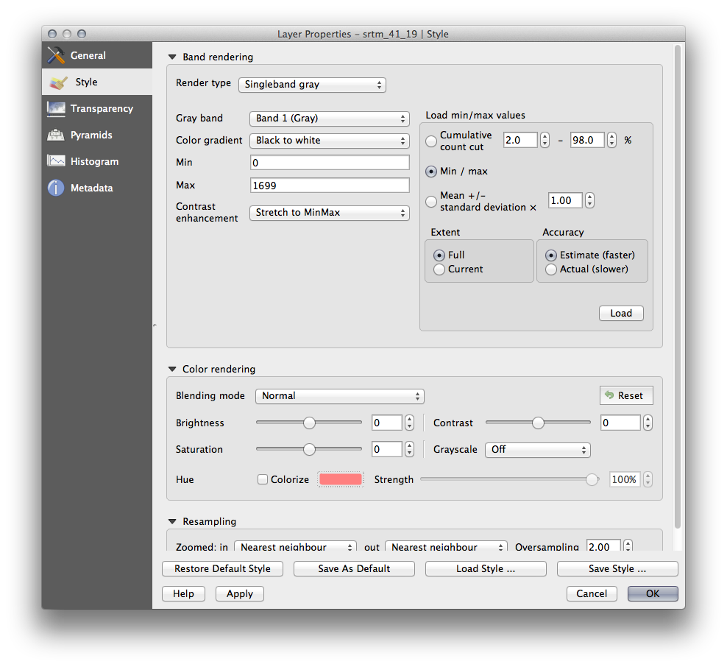

* Click *OK* to apply these settings to the image.

You’ll now see that the values of the raster are again properly displayed, with the darker colors representing valleys and the lighter ones, mountains:

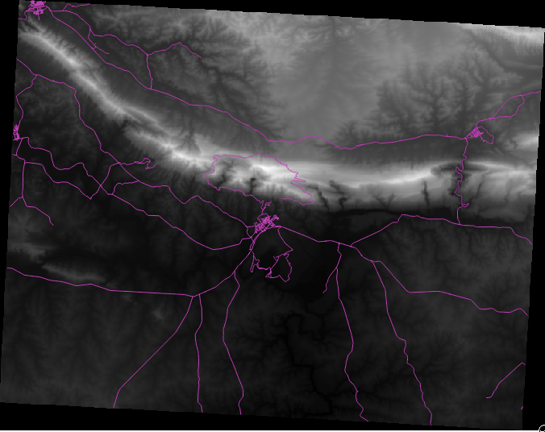

### 4.2.2.1. But isn’t there a better or easier way?

Yes, there is. Now that you understand what needs to be done, you’ll be glad to know that there’s a tool for doing all of this easily.

* Remove the current DEM from the *Layers list*.
* Load the raster in again, renaming it to DEM as before. It’s a gray rectangle again...
* Enable the tool you’ll need by enabling *View ‣ Toolbars ‣ Raster*. These icons will appear in the interface:
* 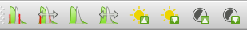

The third button from the left *Local Histogram Stretch* will automatically stretch the minimum and maximum values to give you the best contrast in the local area that you’re zoomed into. It’s useful for large datasets. The button on the left *Local Cumulative Cut Stretch ...* will stretch the minimum and maximum values to constant values across the whole image.

* Click the fourth button from the left (*Stretch Histogram to Full Dataset*). You’ll see the data is now correctly represented as before.

You can try the other buttons in this toolbar and see how they alter the stretch of the image when zoomed in to local areas or when fully zoomed out.

## 4.2.3. In Conclusion

These are only the basic functions to get you started with raster symbology. QGIS also allows you many other options, such as symbolizing a layer using standard deviations, or representing different bands with different colors in a multispectral image.

# 4.3. Lesson: Terrain Analysis

Certain types of rasters allow you to gain more insight into the terrain that they represent. Digital Elevation Models (DEMs) are particularly useful in this regard. In this lesson you will use terrain analysis tools to find out more about the study area for the proposed residential development from earlier.

**The goal for this lesson:** To use terrain analysis tools to derive more information about the terrain.

## 4.3.1. basic Follow Along: Calculating a Hillshade

The DEM you have on your map right now does show you the elevation of the terrain, but it can sometimes seem a little abstract. It contains all the 3D information about the terrain that you need, but it doesn’t look like a 3D object. To get a better look at the terrain, it is possible to calculate a *hillshade*, which is a raster that maps the terrain using light and shadow to create a 3D-looking image.

To work with DEMs, you should use QGIS’ all-in-one *DEM (Terrain models)* analysis tool.

* Click on the menu item *Raster ‣ Analysis ‣ DEM (Terrain models)*.
* In the dialog that appears, ensure that the *Input file* is the *DEM* layer.
* Set the *Output file* to hillshade.tif in the directory exercise\_data/residential\_development.
* Also make sure that the *Mode* option has *Hillshade* selected.
* Check the box next to *Load into canvas when finished*.
* You may leave all the other options unchanged.
* Click *OK* to generate the hillshade.
* When it tells you that processing is completed, click *OK* on the message to get rid of it.
* Click *Close* on the main *DEM (Terrain models)* dialog.

You will now have a new layer called *hillshade* that looks like this:

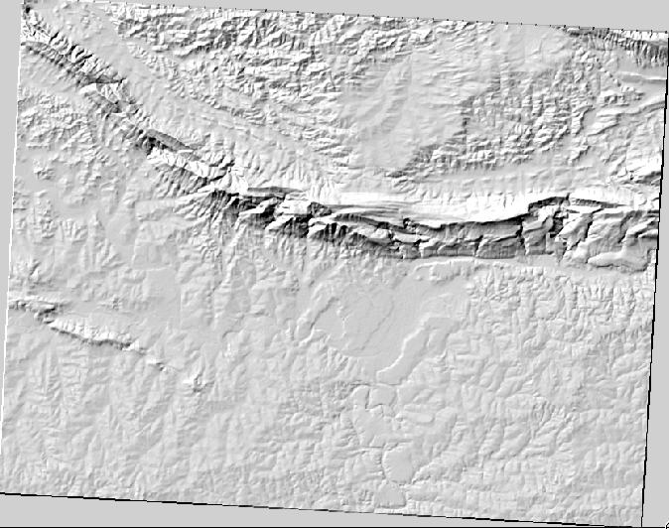

That looks nice and 3D, but can we improve on this? On its own, the hillshade looks like a plaster cast. Can’t we use it together with our other, more colorful rasters somehow? Of course we can, by using the hillshade as an overlay.

## 4.3.2. basic Follow Along: Using a Hillshade as an Overlay

A hillshade can provide very useful information about the sunlight at a given time of day. But it can also be used for aesthetic purposes, to make the map look better. The key to this is setting the hillshade to being mostly transparent.

* Change the symbology of the original *DEM* to use the *Pseudocolor* scheme as in the previous exercise.
* Hide all the layers except the *DEM* and *hillshade* layers.
* Click and drag the *DEM* to be beneath the *hillshade* layer in the *Layers list*.
* Set the *hillshade* layer to be transparent by opening its *Layer Properties* and go to the *Transparency* tab.
* Set the *Global transparency* to 50%:
* Click *OK* on the *Layer Properties* dialog. You’ll get a result like this:
* 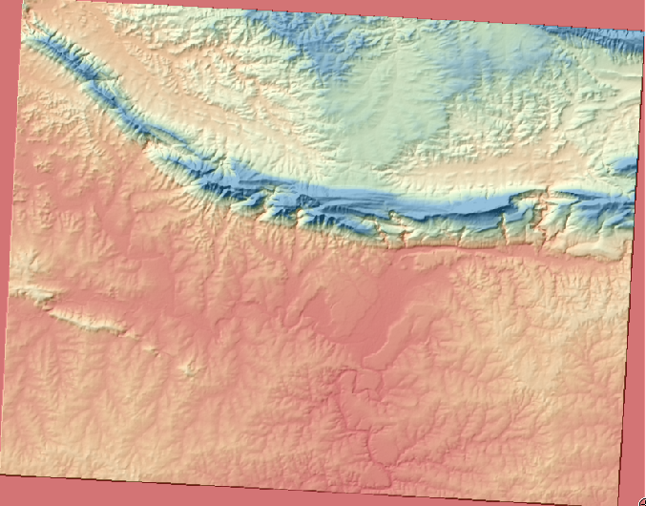
* Switch the *hillshade* layer off and back on in the *Layers list* to see the difference it makes.

Using a hillshade in this way, it’s possible to enhance the topography of the landscape. If the effect doesn’t seem strong enough to you, you can change the transparency of the *hillshade* layer; but of course, the brighter the hillshade becomes, the dimmer the colors behind it will be. You will need to find a balance that works for you.

Remember to save your map when you are done.

Note

For the next two exercises, please use a new map. Load only the DEM raster dataset into it (exercise\_data/raster/SRTM/srtm.tif). This is to simplify matters while you’re working with the raster analysis tools. Save the map as exercise\_data/raster\_analysis.qgs.

## 4.3.3. moderate Follow Along: Using the Raster Calculator

Think back to the estate agent problem, which we last addressed in the *Vector Analysis* lesson. Let’s imagine that the buyers now wish to purchase a building and build a smaller cottage on the property. In the Southern Hemisphere, we know that an ideal plot for development needs to have areas on it that are north-facing, and with a slope of less than five degrees. But if the slope is less than 2 degrees, then the aspect doesn’t matter.

Fortunately, you already have rasters showing you the slope as well as the aspect, but you have no way of knowing where both conditions are satisfied at once. How could this analysis be done?

The answer lies with the *Raster calculator*.

* Click on *Raster > Raster calculator...* to start this tool.
* To make use of the *aspect* dataset, double-click on the item *aspect@1* in the *Raster bands* list on the left. It will appear in the *Raster calculator expression* text field below.

North is at 0 (zero) degrees, so for the terrain to face north, its aspect needs to be greater than 270 degrees and less than 90 degrees.

* In the *Raster calculator expression* field, enter this expression:
* aspect@1 <= 90 OR aspect@1 >= 270
* Set the output file to aspect\_north.tif in the directory exercise\_data/residential\_development/.
* Ensure that the box *Add result to project* is checked.
* Click *OK* to begin processing.

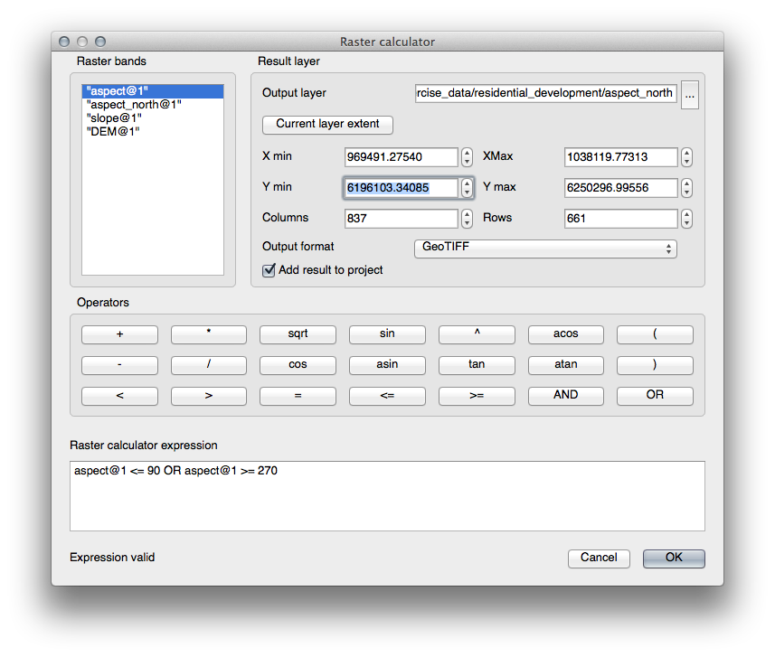

Your result will be this:

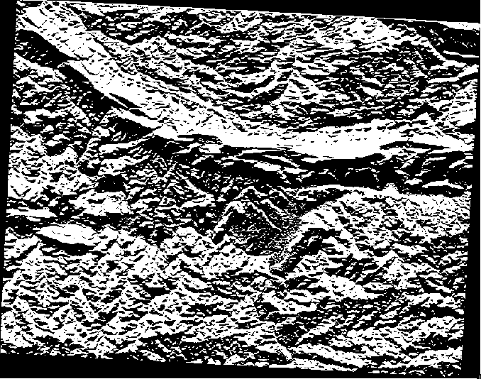

## 4.3.4. In Conclusion

You’ve seen how to derive all kinds of analysis products from a DEM. These include hillshade, slope and aspect calculations. You’ve also seen how to use the raster calculator to further analyze and combine these results.

# 5.1. Lesson: Using Map Composer

Now that you’ve got a map, you need to be able to print it or to export it to a document. The reason is, a GIS map file is not an image. Rather, it saves the state of the GIS program, with references to all the layers, their labels, colors, etc. So for someone who doesn’t have the data or the same GIS program (such as QGIS), the map file will be useless. Luckily, QGIS can export its map file to a format that anyone’s computer can read, as well as printing out the map if you have a printer connected. Both exporting and printing is handled via the Map Composer.

**The goal for this lesson:** To use the QGIS Map Composer to create a basic map with all the required settings.

## 5.1.1. basic Follow Along: The Composer Manager

QGIS allows you to create multiple maps using the same map file. For this reason, it has a tool called the *Composer Manager*.

* Click on the *Project ‣ Composer Manager* menu entry to open this tool. You’ll see a blank *Composer manager* dialog appear.
* Click the *Add* button and give the new composer the name of Dar es Salaam.
* Click *OK*.
* Click the *Show* button.

(You could also close the dialog and navigate to a composer via the *File ‣ Print Composers* menus, as in the image below.)

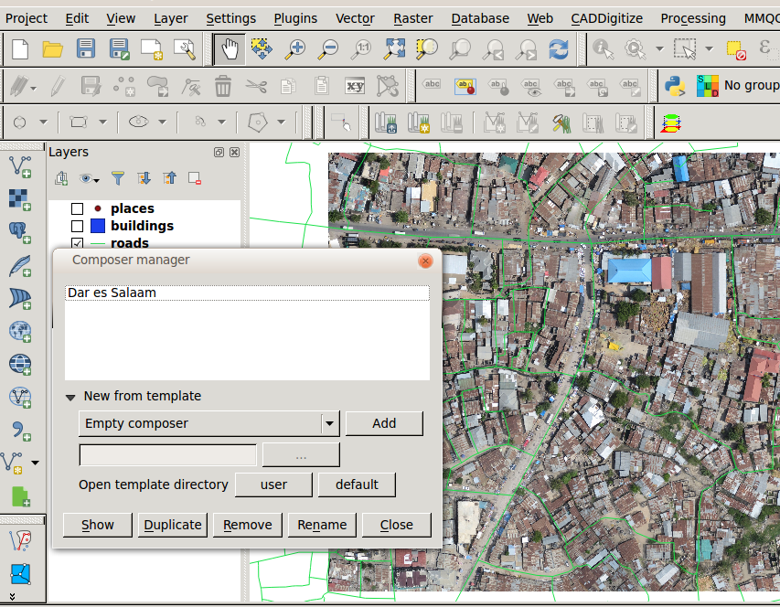

Whichever route you take to get there, you will now see the *Print Composer* window:

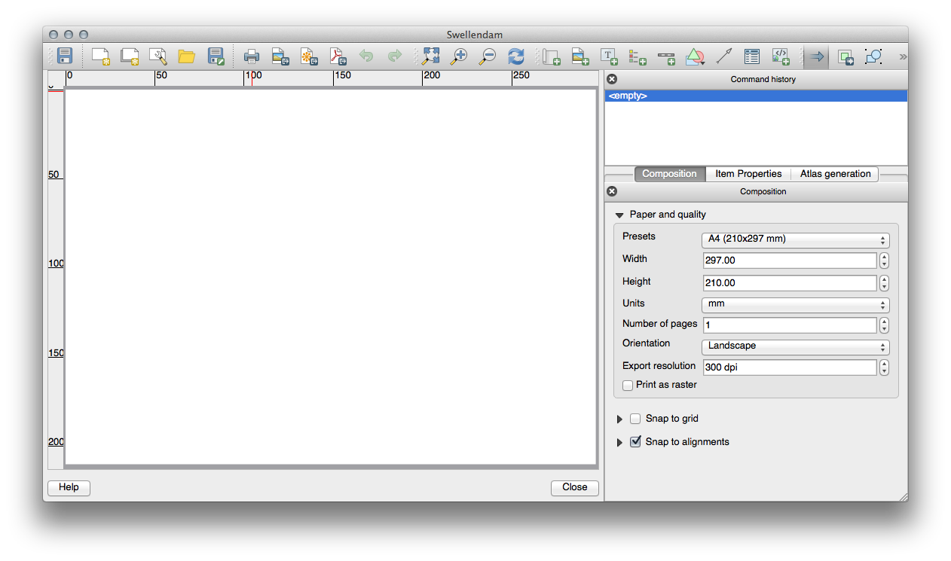

## 5.1.2. basic Follow Along: Basic Map Composition

In this example, the composition was already the way we wanted it. Ensure that yours is as well.

* In the *Print Composer* window, check that the values under *Composition ‣ Paper and Quality* are set to the following:
* *Size*: A4 (210x297mm)
* *Orientation*: Landscape
* *Quality*: 300dpi

Now you’ve got the page layout the way you wanted it, but this page is still blank. It clearly lacks a map. Let’s fix that!

* Click on the *Add New Map* button:

With this tool activated, you’ll be able to place a map on the page.

* Click and drag a box on the blank page:

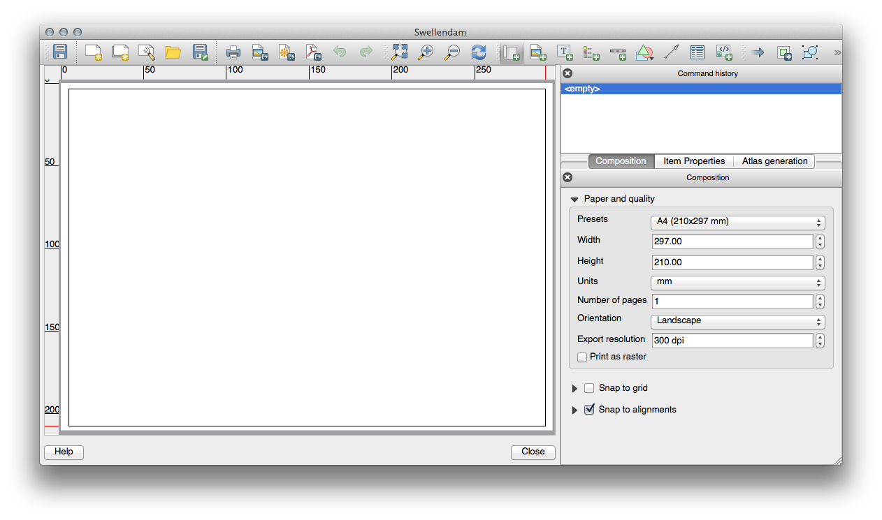

The map will appear on the page.

* Move the map by clicking and dragging it around:

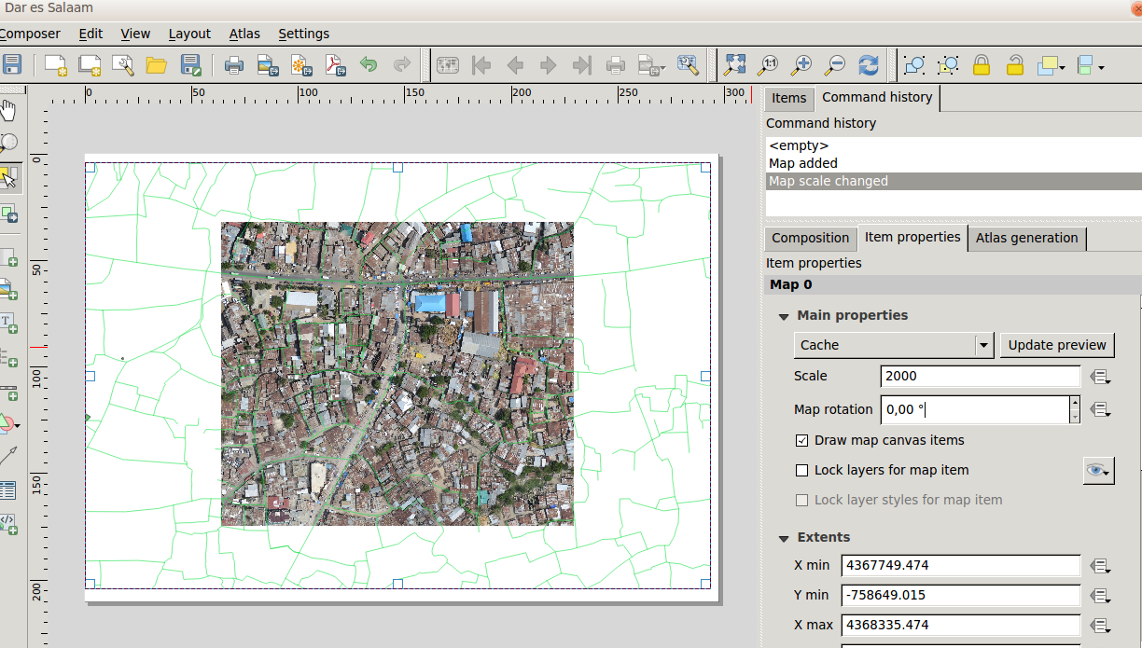

* Resize it by clicking and dragging the boxes in the corners:

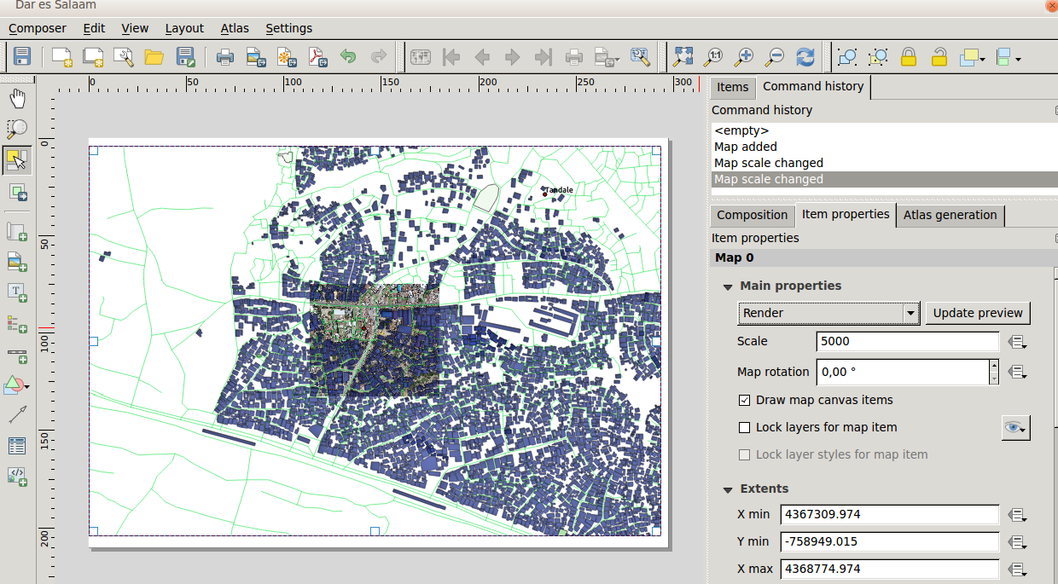

Note

Your map may look a lot different, of course! This depends on how your own project is set up. But not to worry! These instructions are general, so they will work the same regardless of what the map itself looks like.

* Be sure to leave margins along the edges, and a space along the top for the title.
* Zoom in and out on the page (but not the map!) by using these buttons:
* 
* Zoom and pan the map in the main QGIS window. You can also pan the map using the *Move item content* tool:

When zooming in, the map view will not refresh by itself. This is so that it doesn’t waste your time redrawing the map while you’re zooming the page to where you want it, but it also means that if you zoom in or out, the map will be at the wrong resolution and will look ugly or unreadable.

* Force the map to refresh by clicking this button:



Remember that the size and position you’ve given the map doesn’t need to be final. You can always come back and change it later if you’re not satisfied. For now, you need to ensure that you’ve saved your work on this map. Because a *Composer* in QGIS is part of the main map file, you’ll need to save your main project. Go to the main QGIS window (the one with the *Layers list* and all the other familiar elements you were working with before), and save your project from there as usual.

## 5.1.3. basic Follow Along: Adding a Title

Now your map is looking good on the page, but your readers/users are not being told what’s going on yet. They need some context, which is what you’ll provide for them by adding map elements. First, let’s add a title.

* Click on this button:
* Click on the page, above the map, and a label will appear at the top of the map.
* Resize it and place it in the top center of the page. It can be resized and moved in the same way that you resized and moved the map.

As you move the title, you’ll notice that guidelines appear to help you position the title in the center of the page.

However, there is also a tool to help position the title relative to the map (not the page):



* Click the map to select it.
* Hold in shift on your keyboard and click on the label so that both the map and the label are selected.
* Look for the *Align* button and click on the dropdown arrow next to it to reveal the positioning options and click *Align center*:

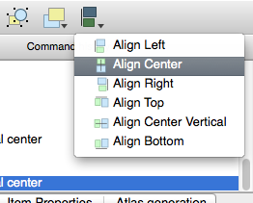

To make sure that you don’t accidentally move these elements around now that you’ve aligned them:

* Right-click on both the map and the label.

A small lock icon will appear in the corner to tell you that an element can’t be dragged right now. You can always right-click on an element again to unlock it, though.

Now the label is centered to the map, but not the contents. To center the contents of the label:

* Select the label by clicking on it.
* Click on the *Item Properties* tab in the side panel of the *Composer* window.
* Change the text of the label to “Swellendam”:
* Use this interface to set the font and alignment options:

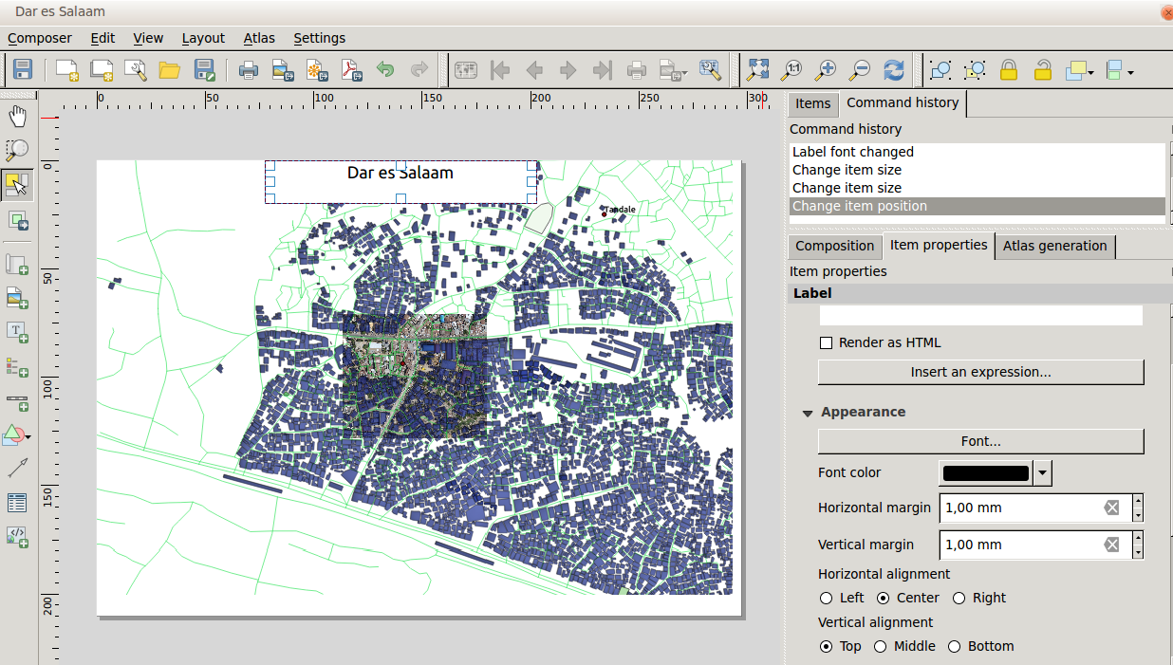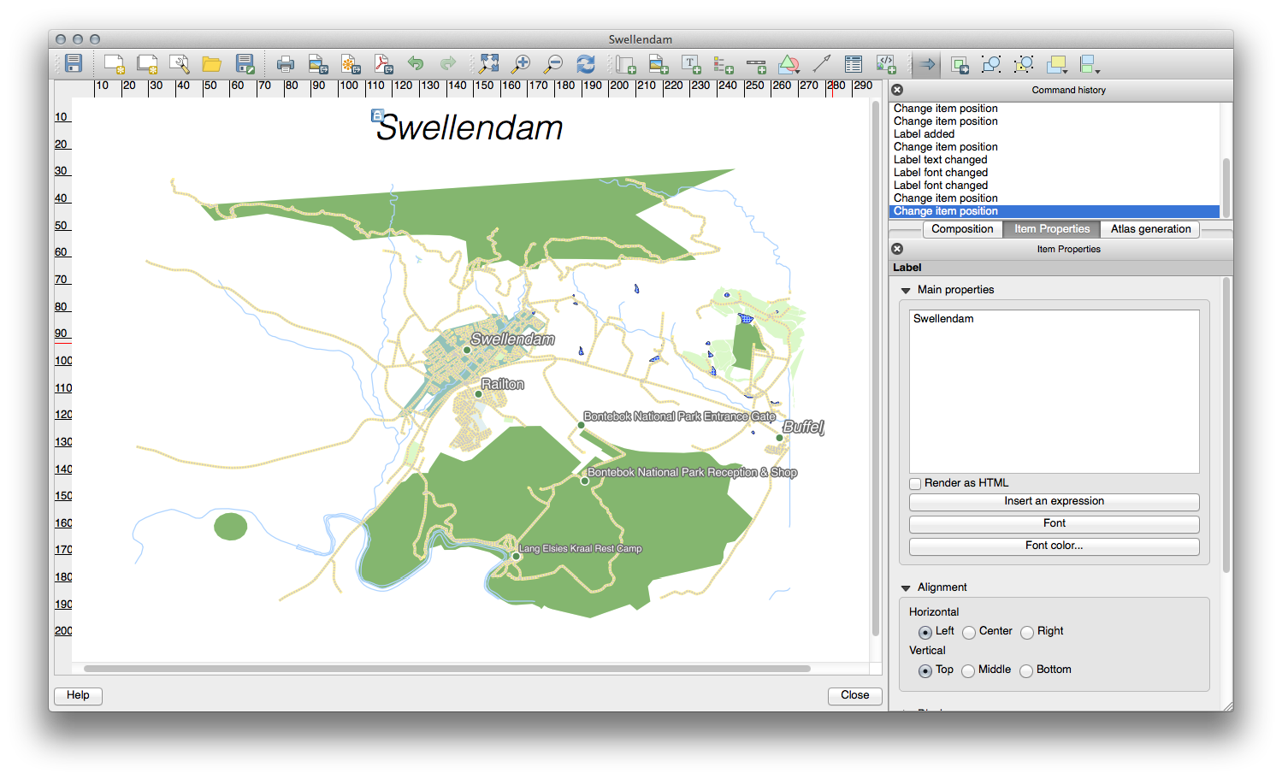

* Choose a large but sensible font (the example will use the default font with a size of 36) and set the *Horizontal Alignment* to *Center*.

You can also change the font color, but it’s probably best to keep it black as per the default.

The default setting is not to add a frame to the title’s text box. However, if you wish to add a frame, you can do so:

* In the *Item Properties* tab, scroll down until you see the *Frame* option.
* Click the *Frame* checkbox to enable the frame. You can also change the frame’s color and width.

In this example, we won’t enable the frame, so here is our page so far:

## 5.1.4. basic Follow Along: Adding a Legend

The map reader also needs to be able to see what various things on the map actually mean. In some cases, like the place names, this is quite obvious. In other cases, it’s more difficult to guess, like the colors of the farms. Let’s add a new legend.

* Click on this button:
* Click on the page to place the legend, and move it to where you want it:

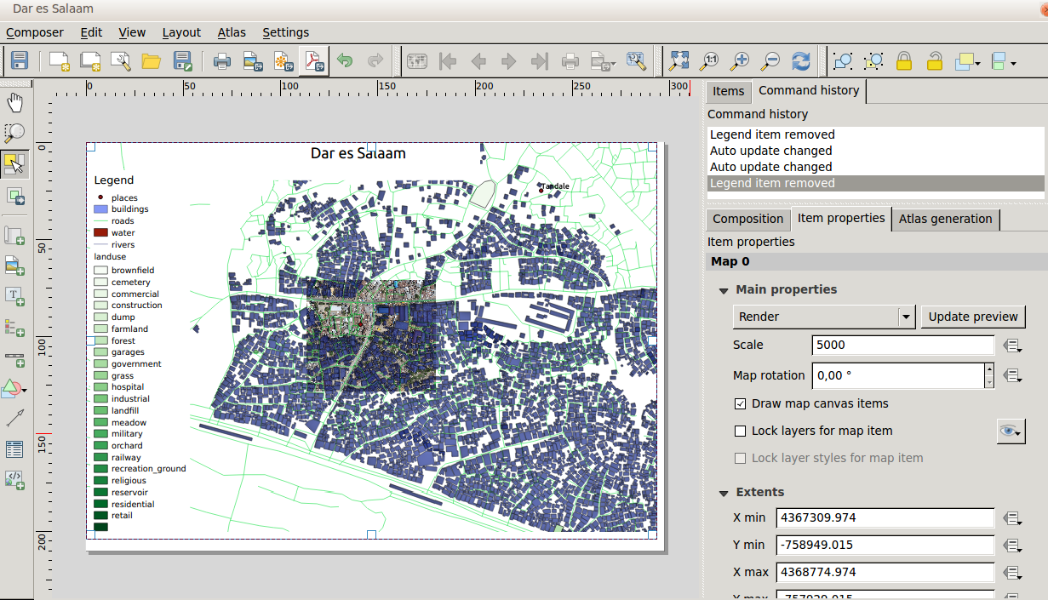

## 5.1.5. moderate Follow Along: Customizing Legend Items

Not everything on the legend is necessary, so let’s remove some unwanted items.

* In the *Item Properties* tab, you’ll find the *Legend items* panel.
* Select the *buildings* entry.
* Delete it from the legend by clicking the *minus* button:

You can also rename items.

* Select a layer from the same list.
* Click the *Edit* button:
* Rename the layers to Places, Roads and Streets, Surafce Water, and Rivers.
* Set landuse to *Hidden*, then click the down arrow and edit each category to name them on the legend. You can also reorder the items:

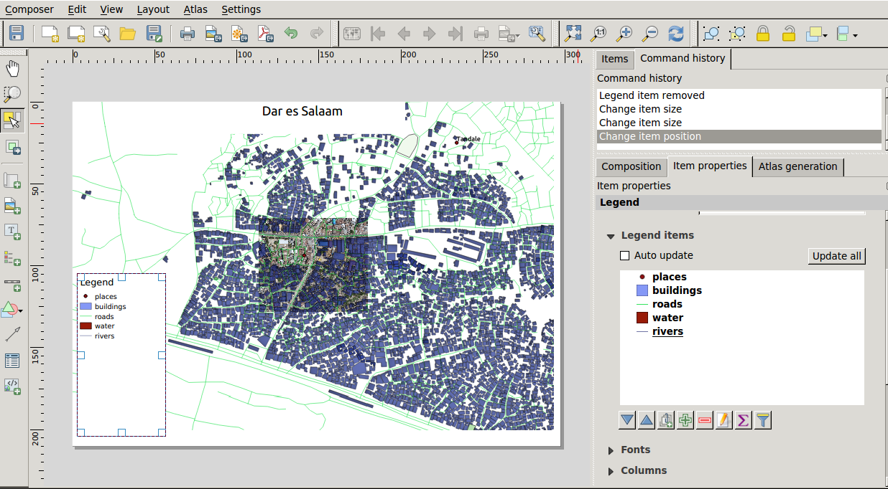

As the legend will likely be widened by the new layer names, you may wish to move and resize the legend and or map. This is the result:

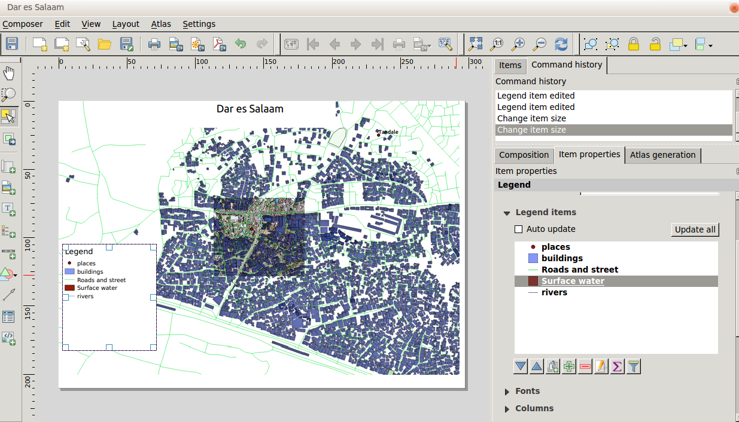

## 5.1.6. basic Follow Along: Exporting Your Map

Note

Did you remember to save your work often?

Finally the map is ready for export! You’ll see the export buttons near the top left corner of the *Composer* window:



The button on the left is the *Print* button, which interfaces with a printer. Since the printer options will differ depending on the model of printer that you’re working with, it’s probably better to consult the printer manual or a general guide to printing for more information on this topic.

The other three buttons allow you to export the map page to a file. There are three export formats to choose from:

* *Export as Image*
* *Export as SVG*
* *Export as PDF*

Exporting as an image will give you a selection of various common image formats to choose from. This is probably the simplest option, but the image it creates is “dead” and difficult to edit.

The other two options are more common.

If you’re sending the map to a cartographer (who may want to edit the map for publication), it’s best to export as an SVG. SVG stands for “Scalable Vector Graphic”, and can be imported to programs like Inkscape or other vector image editing software.

If you need to send the map to a client, it’s most common to use a PDF, because it’s easier to set up printing options for a PDF. Some cartographers may prefer PDF as well, if they have a program that allows them to import and edit this format.

For our purposes, we’re going to use PDF.

* Click the *Export as PDF* button:
* Choose a save location and a file name as usual.
* Click *Save*.

## 5.1.7. In Conclusion

* Close the *Composer* window.
* Save your map.
* Find your exported PDF using your operating system’s file manager.
* Open it.
* Bask in its glory.

Congratulations on your first completed QGIS map project!